# **1st Story - Technological Echoes**

In the twilight of a digitized world, where the echoes of ancient algorithms reverberate through modern existence, the story of *Technological Echoes* begins. This tale, woven from the threads of history, presents a precious clue for unraveling the mysteries of our present and imagining the vast possibilities of our future. As we delve into the chronicles of this cyber village, we find ourselves at a crossroads of memory and innovation. Here, the past is not merely a backdrop but a critical mirror reflecting the distorted images of colonial legacies repurposed by the silicon hands of progress. It is a narrative that challenges us to discern the subtle yet profound ways in which old powers persist, cloaked in the new attire of digital empires. Through this lens, we critically examine how technological advancements, hailed as harbingers of freedom, often perpetuate structures of dominance and exclusion, propelling us into cycles of cyber-colonialism that shape our interconnected destinies.

Like many people of the former colonial countries of the *Global South*, the collective memories of oppression, the pain of war, the disadvantage of living conditions, and the perceived inferior social position, these have become my lingering obsessions.[1] Moreover, among the psychological characteristics of the generation of *millennials***,** continuously in my mind, there is, at once, a feeling of optimism and pessimism regarding the rapid changes in contemporary society which have resulted from technology development and the dominance of cyberspace.[2] For these reasons, I have given special attention to talking about the colonization process and posing a multitude of questions about the existence of colonialism in contemporary society and the danger of its ongoing development in the era of information technology, automation, and global connectivity.

While it was conceived in ancient times, the concept of colonialism is most strongly associated with the European colonial period starting with the 15th century, when nearly one dozen European states established colonizing empires. Colonialism is commonly understood as a practice or policy of control by one person or power over other people or areas, often by establishing coloniesand generally with the aim of economic, political and cultural dominance.[3],[4] The long history of colonialism is divided into four periods: Pre-modern, Modern, 19th Century, and After World War II.

According to Collins English Dictionary, colonialism is ‘the practice by which a powerful country directly controls less powerful countries and uses their resources to increase its power and wealth.’ Therefore, what makes one country more powerful than another? Under what conditions does one group gain the privilege of controlling another? With what potential can colonialism spread?

## **Legend of Miracles**

Based on much evidence and innumerable historical facts, technology has long played an important role in the development of colonialism. Possessing advanced technology is seen as the key to holding the dominant power. Technology is also considered as a measure tool for the level of civilized society and and it has often been the justification given by imperialists for colonization and the homogenization of civilization.

Ancient times, the invention of the *writing system* has been considered the first step in the historical technology of storing and transmitting information. Possessing a written language is a way for a small group of authoritarian people to govern society, history, and collective memory, by what has been purposefully documented. Writing soon became a means of controlling communication and social knowledge. The concept of written words becomes the representative of social intelligence, and the fear of illiterate people is that they will be denied access to that mysterious system of signs. The Mesopotamian cuneiforms, Egyptian hieroglyphs, and Chinese characters are typical examples of the civilized symbols of the three great empires: the three great ancient civilizations in human history.

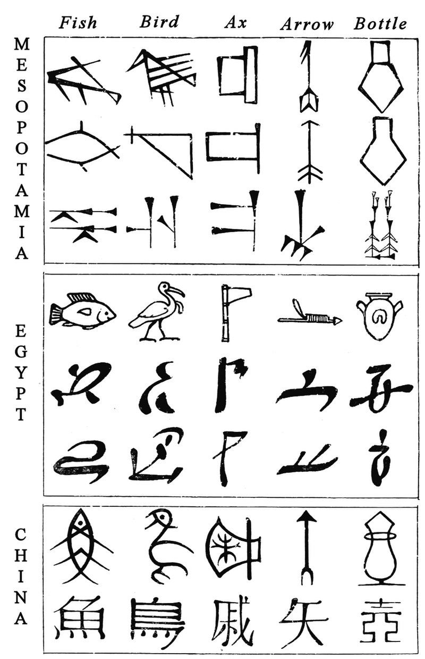

Figure S1. : Ancient writing system: Mesopotamian cuneiforms, Egyptian hieroglyphs, and Chinese characters. From 3500 BC. ©Wikimedia Commons.

In addition, *the fear* of ordinary people in the face of *powerful forces* was associated with *magical movements* - by the primitive automation machines discovered in many places over the world.

As early as Homer, more than 2,500 years ago, Greek mythology explored the idea of automatons and self-moving devices. By the third century B.C., engineers in Hellenistic Alexandria, Egypt, were building real mechanical robots and machines. And such science fictions and historical technologies were not unique to Greco-Roman culture. Chinese chronicles also tell of emperors fooled by realistic androids and describe artificial servants crafted in the second century by the female inventor Huang Yueying. Techno-marvels, such as flying war chariots and animated beings, also appear in Hindu epics. One of the most intriguing stories from India tells how robots once guarded Buddha’s relics. As fanciful as it might sound to modern ears, this tale has a strong basis in links between Ancient Greece and ancient India.[5]

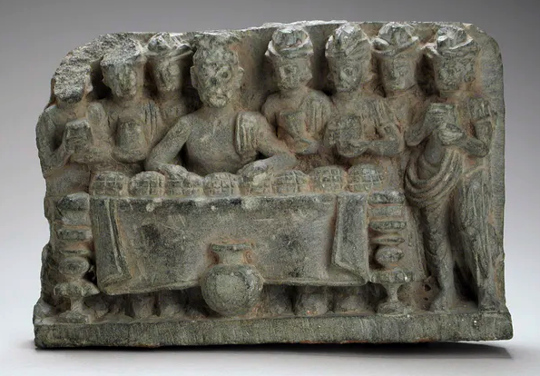

Figure S1. 2: A sculpture depicting the distribution of the Buddha’s relics. ©Los Angeles County Museum of Art.

Some of the very first automated machines, for which technical drawing evidence has been recorded, are the engines of Heron of Alexandria in between the first and third century CE. Heron of Alexandria or Hero of Alexandria (c. 10 AD – c. 70 AD) was a Greek mathematician and engineer who was active in his native city of Alexandria, Roman Egypt.[6] He is often considered the greatest experimenter in antiquity. Heron’s numerous surviving writings suggest that automatic machines were designed to be operated by mechanical or pneumatic means. These included devices for temples to instill faith by deceiving believers with *magical acts of the gods*, theatrical spectacles, and machines like a statue that poured wine.

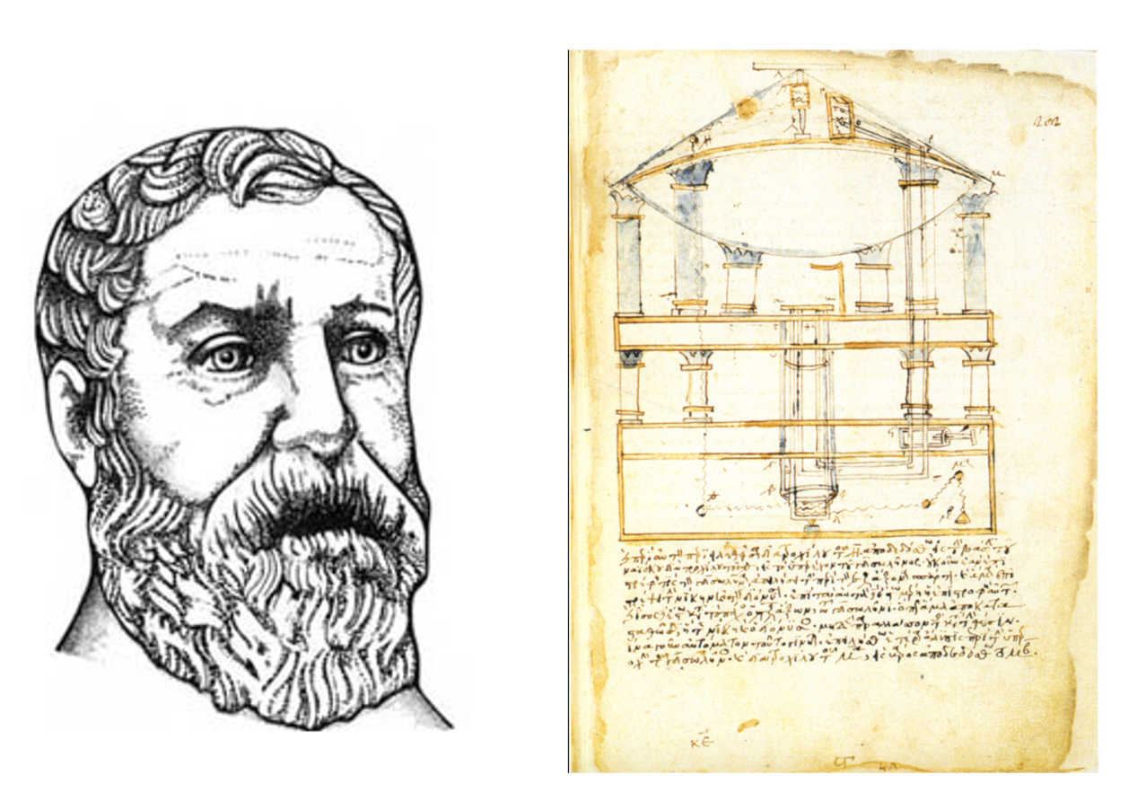

Figure S1. 3: Heron of Alexandria. Diagram of an automaton, a Bacchus figure that dispenses wine and milk in a small temple. The figure has connected by invisible pipes with hidden tanks containing wine and milk. Venice, Biblioteca Marciana, Gr. 516, fol. 202r.[7] This 13th -century codex is the earliest surviving text of Heron's Pneumatica. © historyofinformation.com.

There is evidence from the Middle Ages, between the 5th and 15th AC, of the construction of *robot saints* which could move independently and gesture using complex systems of cogs, hinges, and leather straps, powered by ‘steam, water, or the latent energy held in a winding mechanism like a clock’.[8] The majority of these *robot saints* were made of wood. The still-extant *Iberian robot* *Virgin de Los Reyes* features a painted wooden head, with arms that are covered in white kid skin to give it the appearance of human skin, and hair made from gold thread. The mother's costume is splendidly decorated. It seems that this is a special symbol of spiritual miracles that were presented in the religious life of medieval believers for many centuries.

Since the appearance of primitive automation machines, there has been and remains a compact and complex relationship between illusion and reality and between magical belief and technological reality in the process of manipulation of human perception.



Figure S1. 4: Virgin de Los Reyes – a medieval robot – photo by Ubayrbd. © Wikipedia Commons.

The *power of* *weapons technology* is another example which should not be ignored. Advanced weapons have always been considered a prerequisite in territorial invasions and human control, from ancient times to the present day. The earliest civilizations in southern Mesopotamia, modern-day Iraq, were the Sumerians and Akkadians. The Sumerian warrior was equipped with *spears, maces, swords, clubs, and slings*. Sargon of Akkad (2333–2279 BCE) was a great military leader; he used both infantry and *donkey-drawn chariots* in his powerful army.[9]

The Pharaohs used *horse-drawn war chariots* and various weapons such as improved *javelins, spears,* *curve bows* and *arrowheads,* *catapults*, and *big war galleys* of seventy to eighty tons. These helped them conquer the vast northeast of Africa, ushering in a powerful Egyptian empire that ruled the Mediterranean world for nearly 30 Centuries. – (from Egyptian unification around 3100 B.C. to its conquest by Alexander the Great in 332 B.C.).

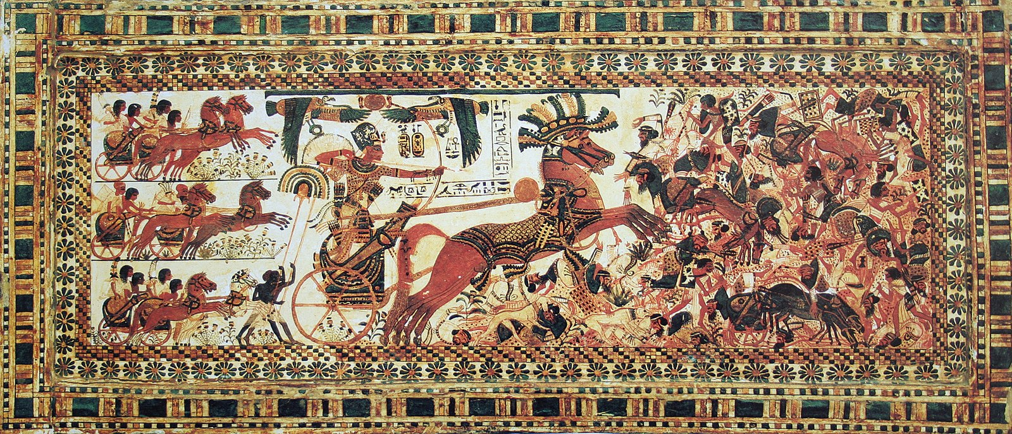

Figure S1. 5: The Pharaoh Tutankhamun destroyed his enemies. ©Wikimedia Commons.[10]

The time after the Egyptian Golden Age was the expansion of the Roman Empire. Differently, the Romans used simple and unusual *weapons of warfare* such as *the gladius swords, spears, plum, shields, and unusual catapults*. The creativity in weaponary contributed to the expantion of the Roman Empire’s domination on large territories around the Mediterranean Sea in Europe, North Africa, and Western Asia over the first three centuries after the common era.

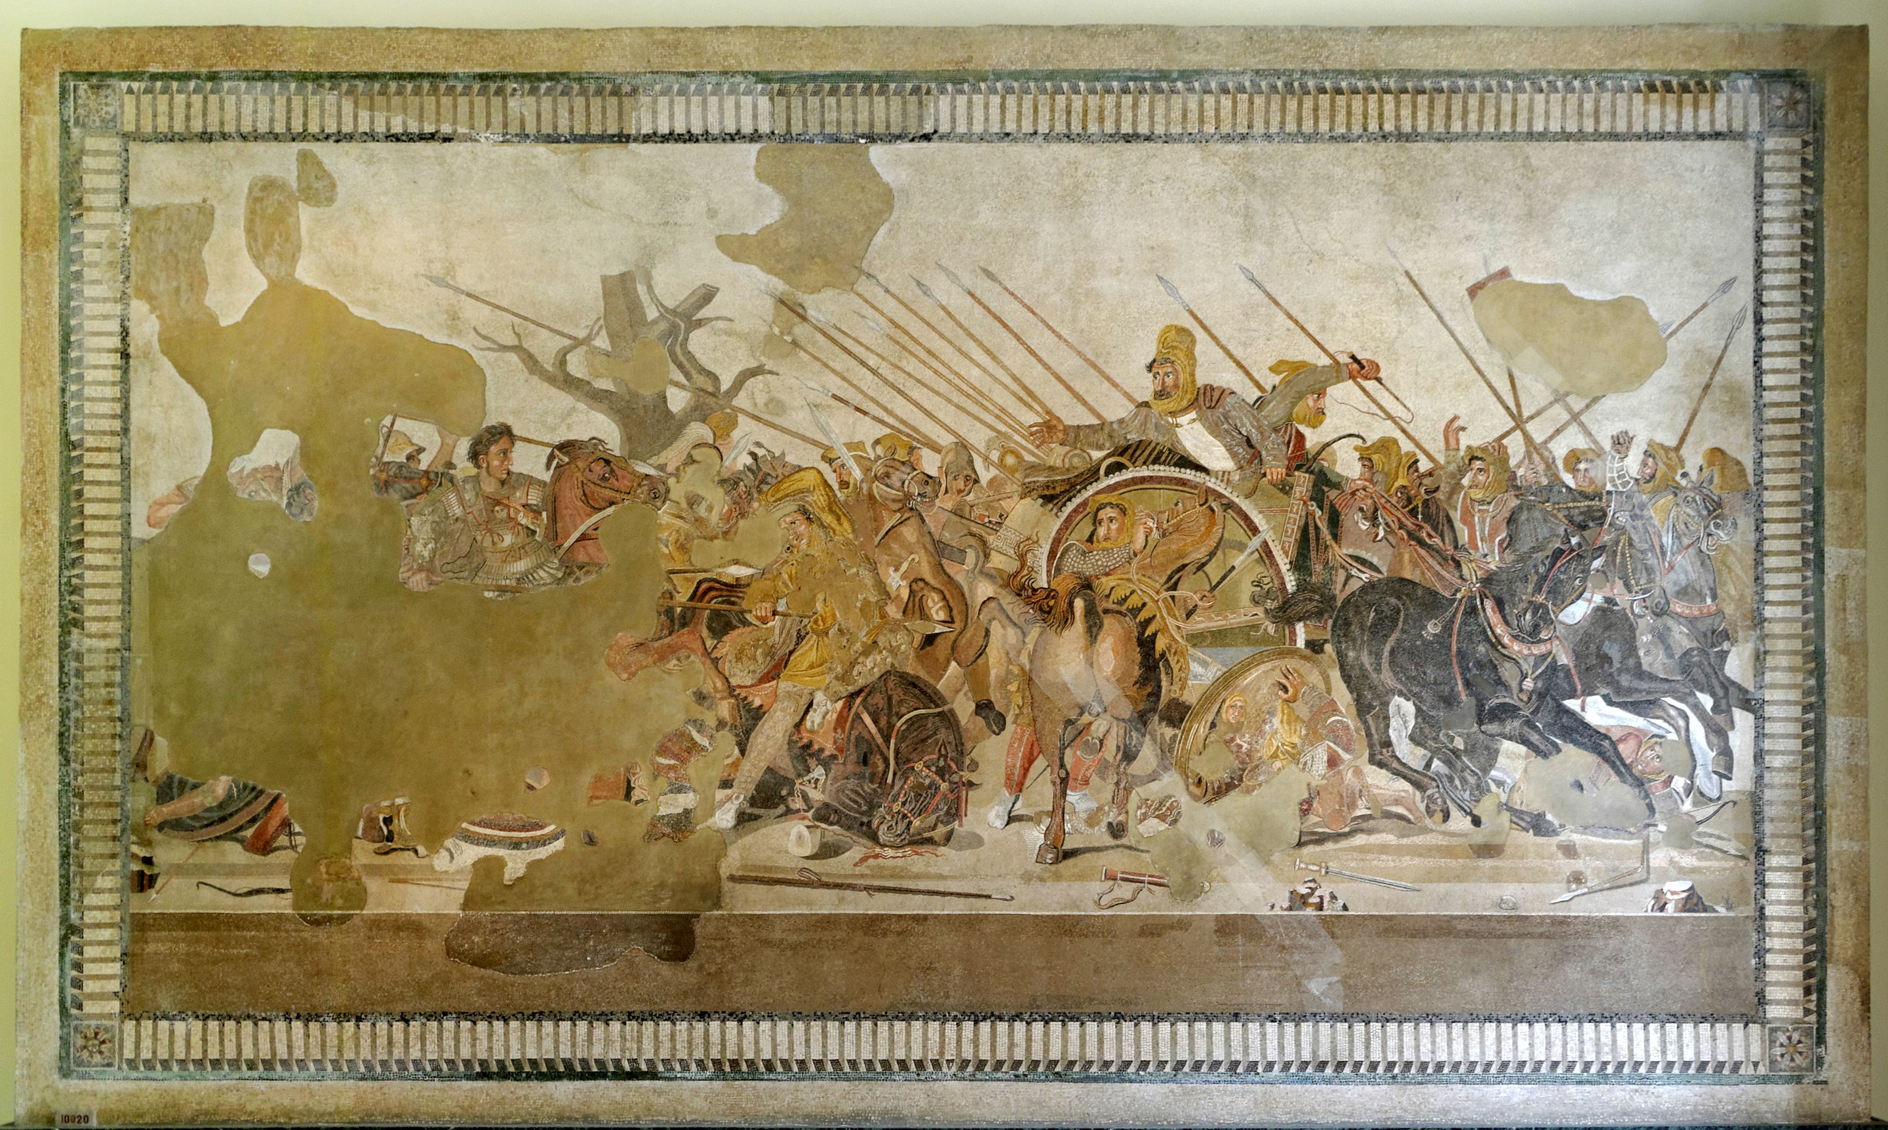

Figure S1. 6: Alexander's battle - mosaic around 100 BC Roman. ©Wikimedia Commons.[11]

The other important inventions such as *paper, printing, gunpowder, and the compass* contributed to the successful of Chinese dynasties on controlling the vast Eastern land. According to English philosopher Francis Bacon, writing in *Novum Organum*:

Printing, gunpowder and the compass: These three have changed the whole face and state of things throughout the world; the first in literature, the second in warfare, the third in navigation; whence have followed innumerable changes, in so much that no empire, no sect, no star seems to have exerted greater power and influence in human affairs than these mechanical discoveries.[12]

Theinvention of *paper and printing technology* contributed significantly to the new information distribution technologies helping the Chinese emperors maintain comprehensive rule, and perfecting the administration of a centralized government.Since the 8th century BCE, *hemp paper* had been used in China for wrapping and padding. The earliest surviving *woodblock printed* fragments are from China. They are of silk printed with flowers in three colors from the Han Dynasty (before 220 A.D.). The earliest examples of woodblock printing on paper also appeared in the mid-seventh century in China.

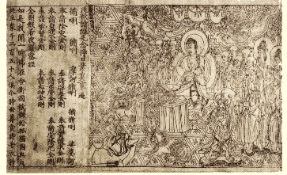

Figure S1. 7: The Diamond Sutra of the Chinese Tang Dynasty, the oldest dated printed book in the world, was found at Dunhuang, in 868 CE. ©Wikimedia Commons.[13]

*Gunpowder* was discovered by the Chinese in the 9th century AD, during the Tang dynasty.[14] They were the first people to systematically use it as weapons on a wide scale. From about 1000 AD, gunpowder has been used in the form of *firecrackers* and, during the earliest days, was used to improve existing weapons by attaching it to spears to create *a shocking burst* on engagement and with arrows to increase their speed mid-air or be shot in large salvos without the need of bows. In the 12th century, the Chinese used crude hand grenades and began to use the earliest form of rockets and cannons in addition to the aforementioned firecracker weapons.[15] There is no doubt that *gunpowder weapons* were a powerful tool of Chinese emperors during their invasions, helping them own most of East Asia for centuries.

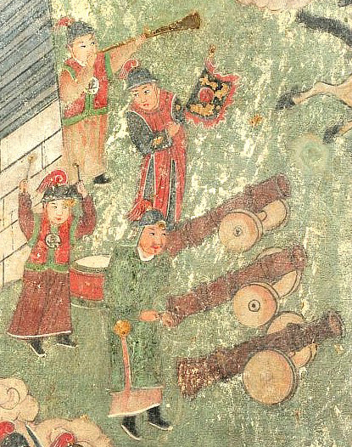

Figure S1. 8: Ming artillerymen from a mural in Yanqing District, Beijing. ©Wikimedia Commons.[16]

In the 3rd century AD, the world's first *compass* *made of lodestone*, the naturally magnetized ore of iron, has also invented during the Han dynasty in China.[17] However, not until the 13th century was the *dry compass* invented in Europe; and it opened a new era for navigation technology, especially helping Europeans to go further. It began to unify the general method of the different pre-existing systems of geolocations. Human movement in general and expeditions to new lands became easier. The new compass also created the initial condition for the first world maps to be formed and is the foundation for an entirely new perception of space for humanity. At the same time, it was the basic advantage for European empires to claim possession of different territories and turn many newly found lands into colonies.



Figure S1. 9: Early modern dry compass suspended by a gimbal (1570) ©Wikimedia Commons.[18]

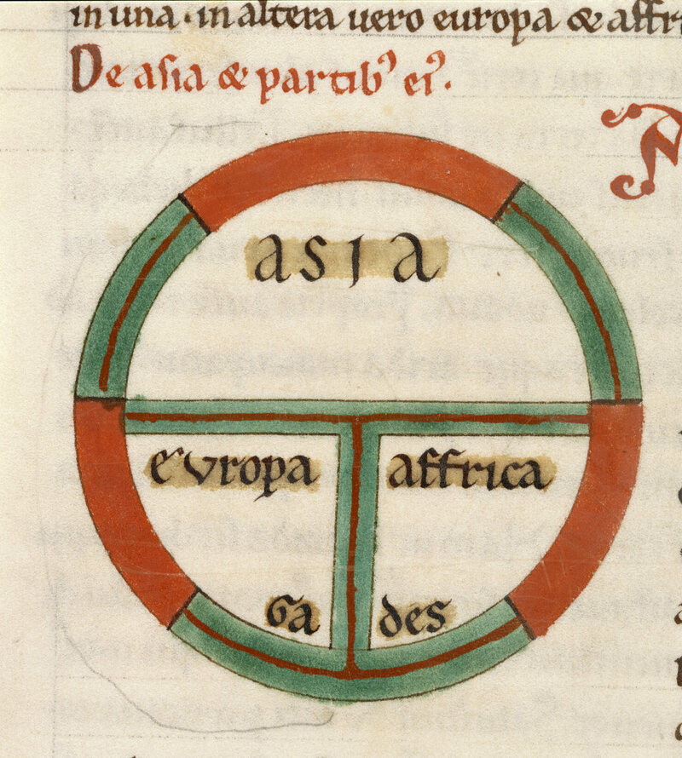

Figure S1. 10: A 13th-century depiction of the world as a circle divided into three continents, Asia, Europe, and Africa. ©British Library.

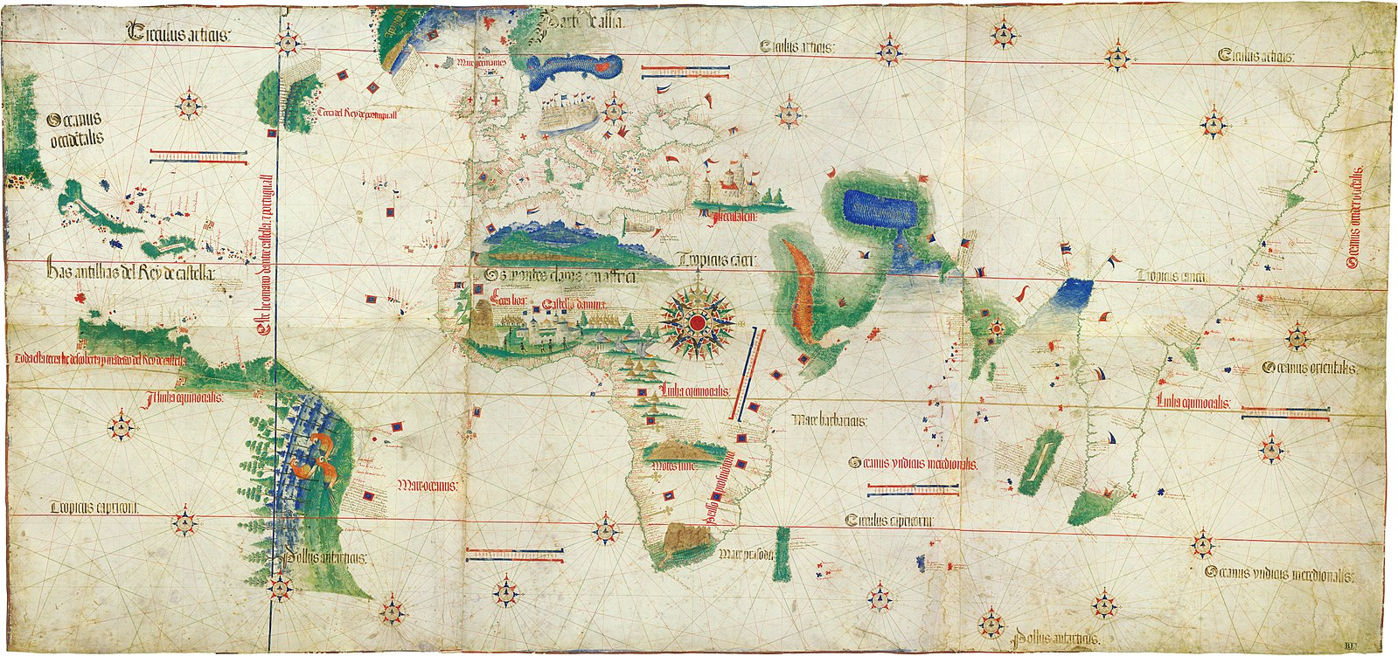

Figure S1. 11: One of the earliest maps to show the New World, the Cantino planisphere (1502) ©Wikimedia Commons.[19]

In addition to the advances in navigation technology, the rapid development of *seagoing ships* in the 13th century ushered in the *Modern time of colonialism* - the *Age of Exploration*. For example, ships developed by the Portuguese: the caravels (in the 13th century) and the carracks (in the 15th century).[20] Portuguese Prince Henry the Navigator (1394–1460) is considered the originator of modern colonialism through explorations and maritime trade with other continents through the systematic exploration of Western Africa, the islands of the Atlantic Ocean, and the search for new routes. Spain (initially the Crown of Castile), soon after Portugal, encountered the Americas (1492 onwards) through sea travel and built trading posts or conquered expansive areas of land.

In succession, the 1st and 2nd industrial revolutions marked an important milestone in colonial history. Especially, the emergence of the *steam engine* and the unprecedented development of mass production capabilities opened up *the golden age of colonialism* in the 19th century to the European empires.

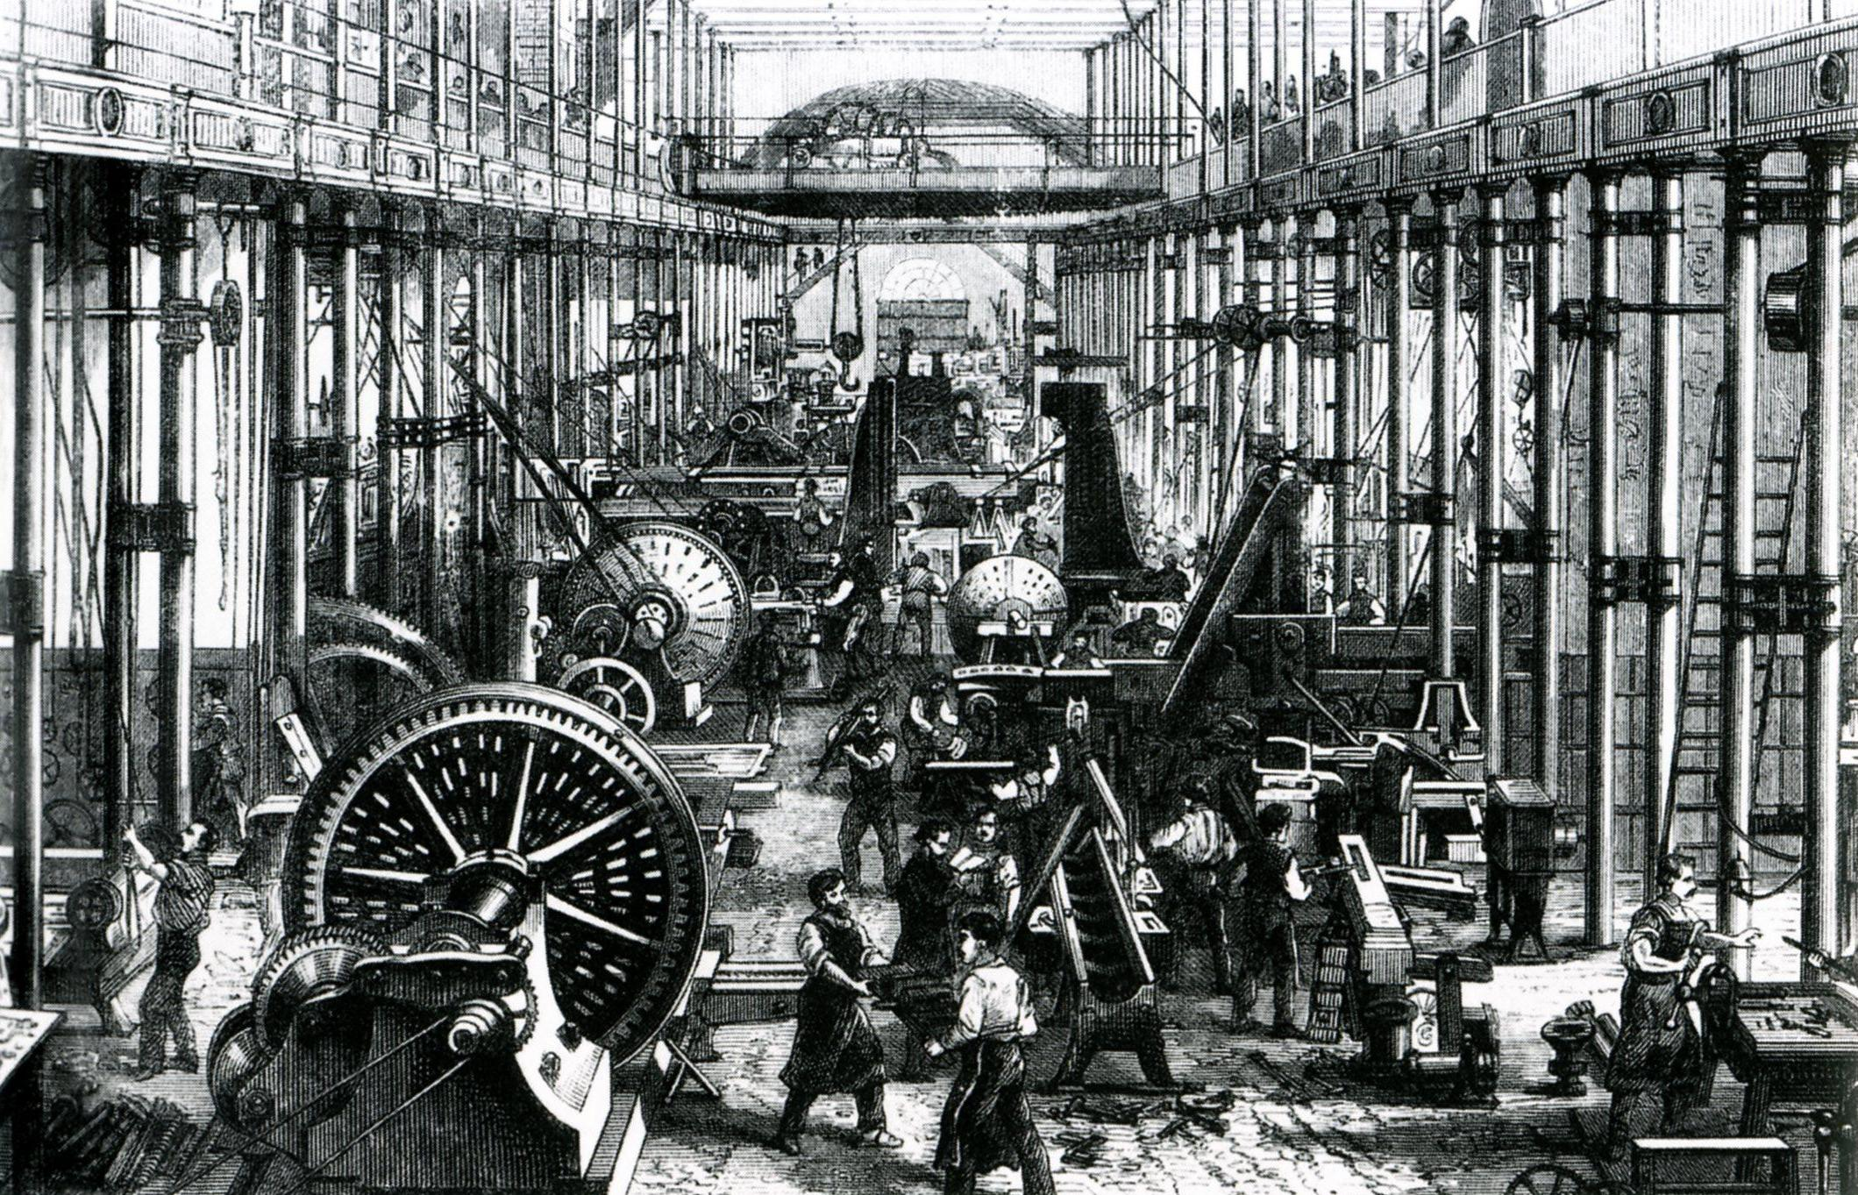

Figure S1. 12: Sächsische Maschinenfabrik in Chemnitz, Germany, 1868. ©Wikimedia Commons.[21]

Most of the land on all continents became European colonies, and the enslavement of indigenous populations became a phenomenon that spread throughout the globe.

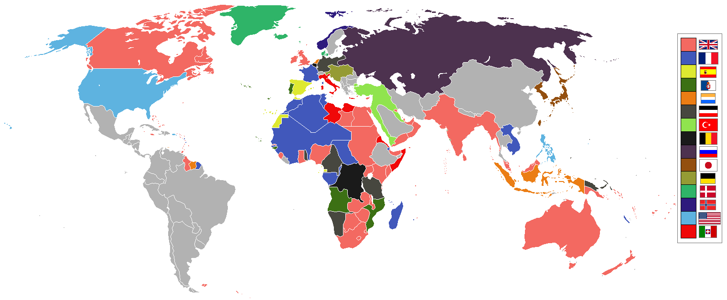

Figure S1. 13: Map of colonial and land-based empires throughout the world in 1914 CE. ©Wikimedia Commons.[22]

The world's colonial population at the outbreak of the First World War (1914), one of the highest points for colonialism, totaled about 560 million people. These peoples lived as possessions of various colonial powers: 70% as British, 10% as French, 9% as Dutch possessions, 4% as Japanese, 2% as German, 2% as American, 3% as Portuguese, 1% as Belgian and 0.5% as Italian.

The world's first *steam-powered seagoing ships* helped British and French become the most powerful invaders of the 19th century; these vessels helped them take over the world leadership positions of the Portuguese and Spanish. The great improvement in *gunboat construction* in British ports made Britain the motherland of 70% of the global colony. On the foundation of the iron and steel processing industry, British ships that were previously entirely made of wood were replaced by iron materials. The material change in shipbuilding technology allowed the new ships to withstand extreme weather on the sea and enduring battles with natives.

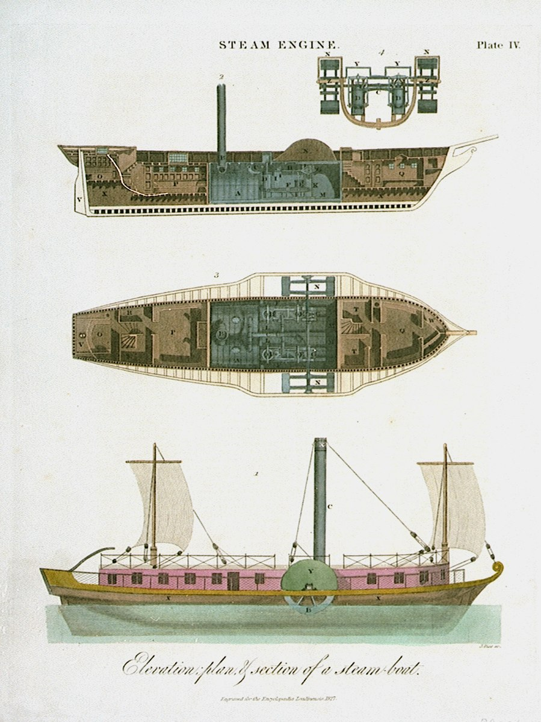

Figure S1. 14: Engraving of the elevation plan and section of a steam-boat, 1827. ©Wikimedia Commons.[23]

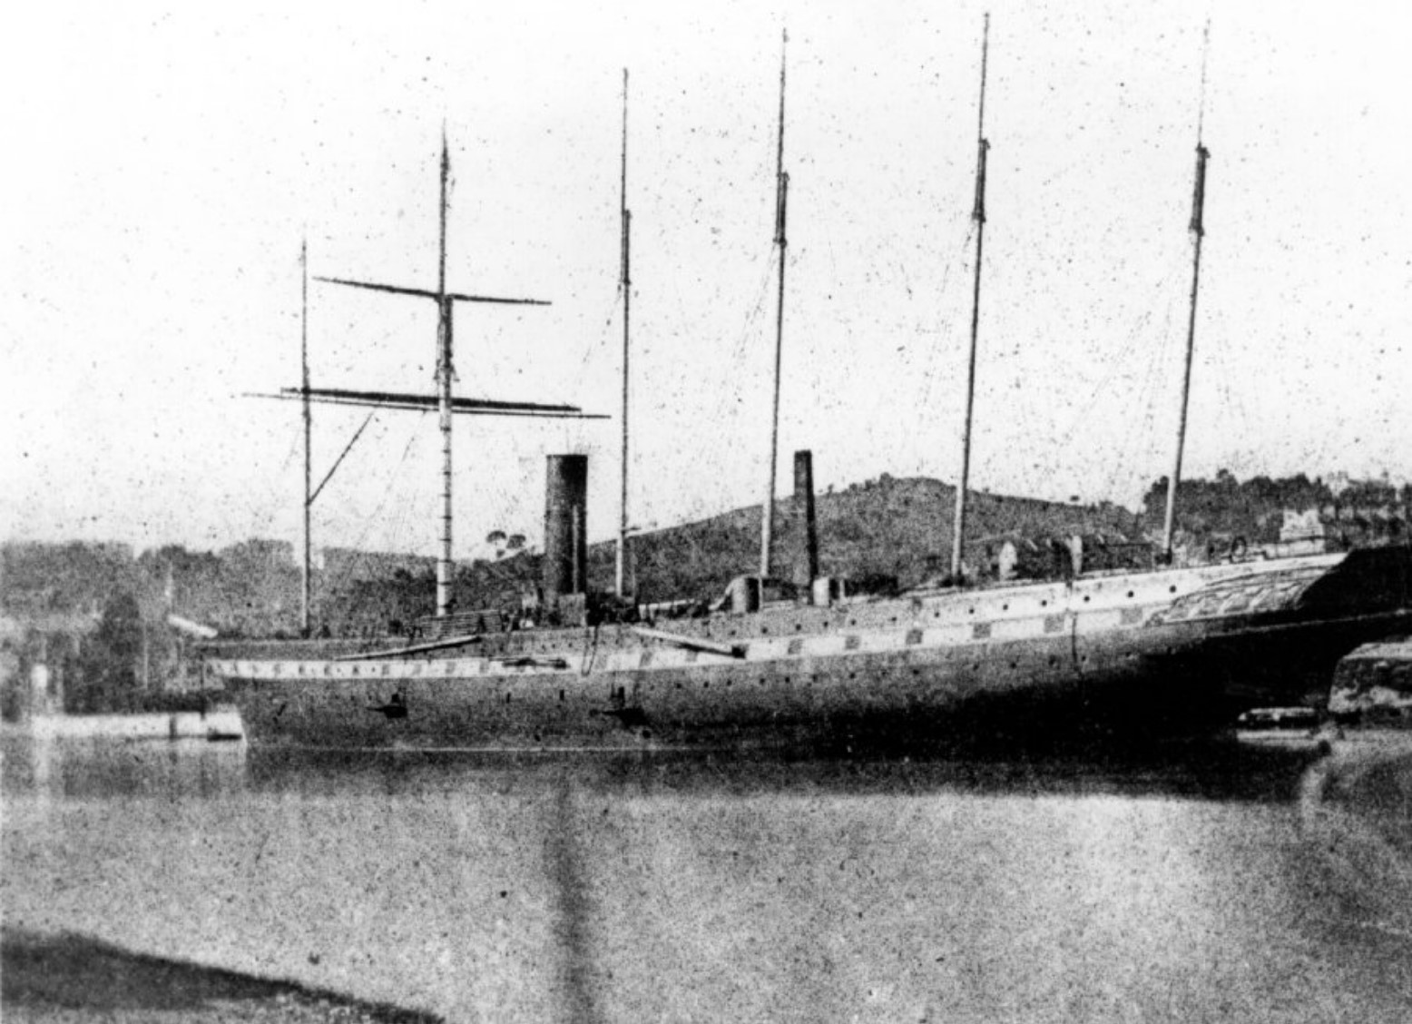

Figure S1. 15: Great Britain in the Cumberland Basin, April 1844. ©Wikimedia Commons.[24]

Industrial factories flourished at the end of the 19th century in many western European countries. The *weapons* and *machine gun industries* dramatically widened the power gap between Europeans and non-Western peoples and led directly to the burgeoning of imperials in the early 20th century. With high production capacity, dangerous levels of damage, and high accuracy, machine guns were the colonists' powerful symbol and the fear of the natives. Daniel R. Headrick once wrote:

By the 1890s, the gun revolution was complete. Most European infantrymen could now fire fifteen rounds of ammunition in as many seconds, lying down undetected, in any weather, with an effective range of up to half a mile. Machine gunners had even more power. Though the generals were not to realize it for many decades, the age of raw courage and cold steel had ended, and the era of arms races and industrial slaughter had begun.[25]

In addition, advances in *medicine and pharmaceuticals* also created unique advantages for European people. In the 18th century, under the influence of the Age of Enlightenment, the modern hospital began to appear, serving medical needs and being staffed with trained physicians and surgeons. Modern medical methods were systematically applied to cure patients.[26] These hospitals were the civilized symbol of imperial countries, the foundation for *military hospitals*, and the advantage of preserving forces for the colonial repressions.

Especially in *pharmaceutical technology*, the successful extraction of *Quinine* in the 19th century was the key to opening Africa's colonial time delayed by deadly malaria for more than four centuries.[27] For a long time, the barrier of disease, most notably malaria, made Europeans hesitant to invade Africa. Many called Africa ‘the white man’s grave,’ and it was known as a death trap for soldiers.[28] From 1819-1836, more than 48.3% of British troops sent to Sierra Leone died.[29] A morbid rhyme sung by British sailors about the Bight, or Bay, of Benin exemplifies the European fear of Africa: ‘Beware, oh beware, of the Bight of Benin, Where few come out although many go in.’[30] However, quinine had the potential to change the entire situation.

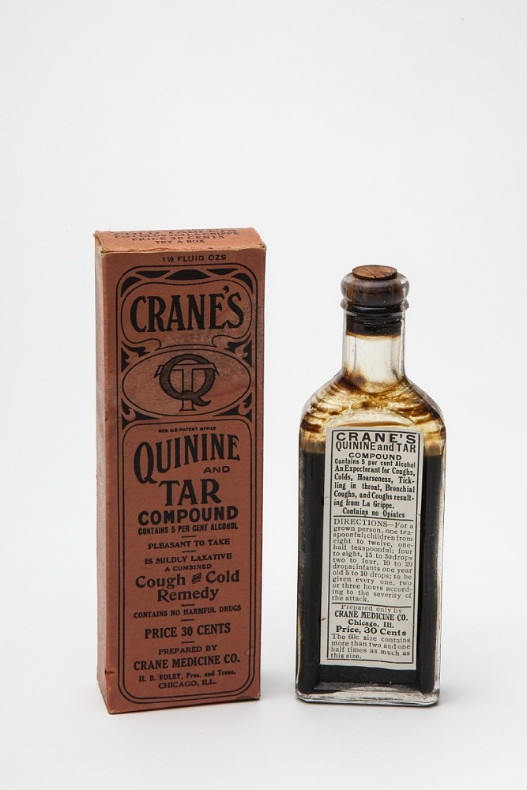

Figure S1. 16: Crane's Quinine and Tar Compound, 19th Century Medicine Bottle with Box. ©National Museum of American History.

*Electrical science* is another technological achievement that developed rapidly in the early 19th century and became an integral part of modern life in the 20th century. The early 19th century had seen rapid progress in electrical science, and the late 19th century would see the greatest progress in electrical engineering. The electrical applications have long contributed significantly to strengthening the military force of the US and European countries. *Searchlights* were one military tool popularly used by imperialist countries when electrical engineering flourished in the late 19th and early 20th centuries. The first use of searchlights using carbon arc technology occurred during the Siege of Paris during the Franco-Prussian War. The British Royal Navy used searchlights in 1882 to dazzle and prevent Egyptian forces from manning artillery batteries at Alexandria. Later that same year, the French and British forces landed troops under searchlights. By 1907 the value searchlights had become widely used among European Empires.

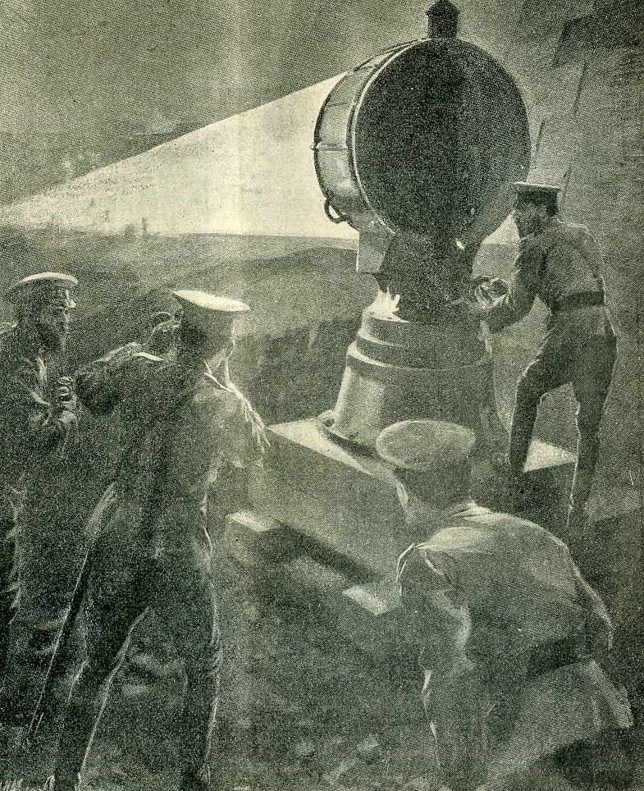

Figure S1. 17: Russian troops use a searchlight against a Japanese night attack during the Russo-Japanese War, 1904. American searchlight crew and equipment in France during WWI. ©Wikimedia Commons.[31]

Driven by the 1st and 2nd industrial revolutions, Western society witnessed the unprecedented emergence and development of *photography*. Shortly after, the first camera image had been captured by Nicéphore Niépce in 1826, and photographs of war events were born in 1855. Since then, photography has become an indispensable new technological tool associated with the Western civilization concept. Western photography orientated other parts of the world in how to record history and lives. To this day, photography contributes to the creation of social standards or norms that are represented and recorded through photos. From the beginning to the present day, photography has been become a universal means of evaluating the level of civilization of individuals and the identity of a country or region.

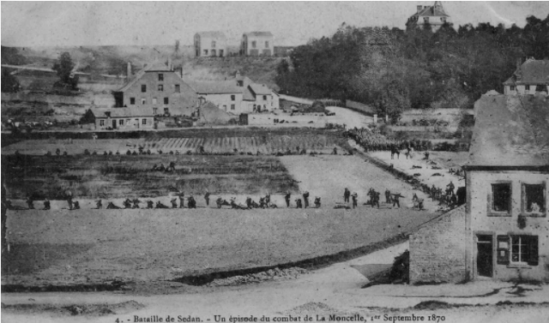

Figure S1. 18: This 1870 image is considered the first actual photograph taken of a battle. It shows a line of Prussian troops advancing. The photographer stood with the French defenders when he captured this image. ©militaryhistorynow.com.[32]

**

Figure S1. 19: A man in Iyede, Delta State, Nigeria, 1909. ©theguardian.com.[33]

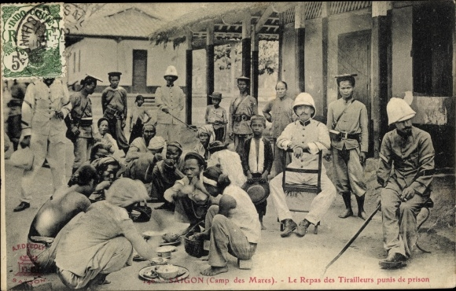

Figure S1. 20: Postcard Saigon Cochinchine Vietnam, Camp des Mares, le Repas des Tirailleurs punish de prison. ©akpool.co.uk.[34]

After World War II (1939–1945), decolonization progressed rapidly, and a series of colonial states declared their independence. However, the colonial relationship had not really come to a halt; it had transitioned to a new stage, a postcolonial or neocolonial period. Especially in the late 20th and early 21st centuries, based on the development of *computer science, cloud storage, Big Data, IoT, and AI,* this dominance of one power over another has become more profound, more dangerous and considerably broader in scope. Once again, the owners of advanced technologies take over the power position and set the rules for all of political, economic, and cultural relations.

Similar to thousands of years ago, the majority of advanced technologies have been applied to the military industrial complex and the neo-colonizer has again employed the power of weapons to demonstrate prestige and to threaten smaller, less developed countries. *Supersonic aircraft, stealth submarines, generations of weapons,* and *AI-controlled robots* have been developed and put to use widely in the technologically developed countries.



Figure S1. 21: Boston Dynamic's robots, ©newatlas.com. Blackbird supersonic aircraft, ©popularmechanics.com. Israel’s Rafael integrates artificial intelligence into Spice bombs Illustration of Japan's new Epsilon AI rocket, ©c4isrnet.com.[35], [36], [37]

Holding advanced *weapons technology* and *dominating cyberspace* are considered among the most important goals of developed countries. Cyberspace has become another living space inseparable from real life in the 21st century. Connectivity through cyberspace is an indispensable activity in many countries, corporations, organizations, and for the majority of global citizens. Never before have we witnessed such a close connection between digital devices and the human body as today. Consequently, intervention in digital space is a core issue for dominating the life of modern people, making the race over technology more important than ever. In reality, new technology empires are attempting to assert control over human life through digital means, establishing a form of *cyber colonialism* around the world.

## **The Usurper**

‘Technology is a useful servant but a dangerous master.’– Christian Lous Lange.[38]

Since the onset of the digital revolution and the initial development of the computer sciences in the 1960s and 1970s, there have been concerns regarding the revival of colonialism. The conceps *electronic* *colonialism* or *digital colonialism*, sometimes abbreviated to *eColonialism*, were conceived by Herbert Schiller as documented in his 1976 text Communication and Cultural Domination.[39] The idea of cyberspace took on increasing interest in the 1990s with the growing popularity of the internet, networking and digital communication.[40] Not much later, in the article *Cyber-colonialism in Asia: more imagined than real?* by Loo & Beng in 1998, the concept of *cyber-colonialism* was mentioned.[41] Despite its *technological optimism* regarding global connectivity in the internet space, Loo & Beng's writing has contributed significantly to the discussion of the issue since the early days of the era of global connectivity.

The cyber-colonialism discussed by Loo & Beng is an exaggerated idea of media imperialism by the newly independent states. However, in the current circumstance, with the unprecedented speed and complexity of cyberspace, this understanding no longer seems appropriate. Cyberspace should be understood as a comprehensive digitally-interconnected space, including the public network and private networks (the interconnection between machines in single systems). Hegemony in cyberspace is not only reflected in media but also in different aspects of human life including politics, economy, technology and society. The empires that dominate cyberspace are not only media empires but also many other empires constantly forming along with the development of new technologies, such as cloud empire, search empires and social network empires. Therefore, in our story, Cyber-colonialism is seen as a practice of control, manipulation and exploitation by technological owners over people, often by establishing *technological hyper-dependent relationship* and with the aim of all human being dominance.

Cyber-colonization seems to be triggered when people *start to connect* to digital devices. People today are connected intimately through machine systems, whether direct or indirect users. Human existence, in different ways, is all connected to digital devices and/or digital connected systems. Currently, the surveillance camera system is widely used by individuals, companies, organizations and government agencies. In the street, on the shops, in front of each house, the ubiquitous security camera is the foremost example of the relationship between modern people and the equipment around them. The dense satellite system surrounding the earth is another surveillance, connectivity, and dominance tool, with a broader impact; It affects not only individuals but also organizations, countries, regions, and even entire continents. Additionally, public surveillance cameras and personal electronic devices have the potential to capture endless habits and details of public life.

Overall, the level of *technological surveillance* has paralleled the level of digital connectivity of humans in cyberspace. The greater the connection to electronic devices, the higher the user's dependence on vehicles. The longer the software is used, the higher the level of user exploitation and control by service providers. Out of individual control, users' level of digital connectivity is increasing at an unprecedented rate globally. The extension of the human body to machines is no longer a prediction as seen in Donna Haraway’s early remarks in *A Cyborg Manifesto*, but has become a reality of contemporary mankind.[42] In Haraway's opinion, the cyborg's integration of technology into its body creates a new form of embodiment that challenges the dichotomy between mind and body. By merging with machines, the cyborg becomes a new kind of being that is both physical and virtual. This extension of the human body to machines also allows for new forms of agency and control. The cyborg's ability to manipulate technology and navigate virtual environments gives it a new kind of power that can be both liberating and dangerous. The simplest example is that smartphones have become an integral part of the majority of people in this day and age.

Behind the self-imposed consumer needs, users have been dominated by *demand-producing machines* founded by technology owners. In order to increase the ability to monitor, exploit and control society, and dominate markets and create profits and power, technological empires constantly promote demand and desire for consumption, using different tactical strategies, among which we must count the *all-in-one package* products and services—the attractive *digital ecosystems*. The majority of giant technological owners today have created a cross-link between services and products in the same system, forming a matrix of associated features and utilities. Along with many advanced elements such as speed, ease, convenience, and efficiency, these digital packages always represent remarkable exclusivity and bondage. Developing these attractive and exclusive digital ecosystems is the ambition of many nations, organizations, companies, and corporations around the world.

Many governments are constantly digitizing their citizens' information. The digital identity system was introduced to link all public administrative procedures, through which to control all civil activities. China's Social Credit System is one example. In China, the vast majority of urban residents can do all their social activities via electronic devices, most commonly through smartphones. Academic studies, medical visits, payments and credit operations, and public administrative procedures can all be done online. Many administrative tasks would be impossible or extremely difficult to implement without an electronic account. In general, in many large cities, the social activities of Chinese people are recorded and updated to the electronic information system through various forms. That information can be both very general and detailed. For example, the state is able to collect information about whether citizens dump their garbage and refuse in the appropriate areas or whether people have parked their vehicles in assigned places. Seemingly endless categories of personal information, such as family biography, education level, occupation, medical information, properties, finances and history of social activities have been recorded, linked, and evaluated by computer systems. Citizens are classified and blacklisted or whitelisted based on data analyzed by the mechanized system.[43]

By participating in the *Google ecosystem*, logging into a Google account, users can use a wide range of products and services such as Google Mail, Google Drive, Google Chat, Google Classroom, Google Meet, Google Fit, Google Translate, Google Calendar, Google Map, Google Play, Google Search, Google Ads and YouTube. All these services are interlinked in one system. For example, if a Gmail user intends to send an email with an attachment that is larger than 25MG (megabytes), the user must link to their Google Drive account. Furthermore, if they need to access a shared group file on Google Drive, the user must create a Google account if they do not already have one Users who need to make notations on Google Maps must have a Google account. These chaining constraints developed by Google have allowed them to engage over one billion customers in the use of their products through 2022.[44] Moreover, the engagement of these customers has allowed Googleto capture and store a vast amount of diverse, detailed and valuable information for the company’s use.

The technology company Apple Inc provides a *system* of *personal electronic devices* such as iPhone, iWatch, iPad, iMac, iTVbox, iPod, Air Pod, Home Pod, and Apple Watch, which all include free operating systems such as mac OS, iOS, iPad OS, watch OS and TV OS. Additionally, Apple Inc has created many *online services* such as the iTunes Store, iOS App Store, Mac App Store, Apple Arcade, Apple Music, Apple TV +, iMessage, and iCloud. *Offline services* include Apple Store, Genius Bar, Apple Care; and *financial services* include Apple Pay, Apple Pay Cash, and Apple Car. In addition, millions of *specialized software* programs written specifically for Apple operating systems are provided by App Store systems. The customers’ level of commitment to the company has been maximized because of Apple’s fully packaged provision of products and services. For example, Apple Watch users cannot install the operating system of the watch device without using their iPhone, nor can they download music to the system without accessing iTunes. This strategy has helped Apple become the leader in sales of personal electronics products globally over the past decade, with a net revenue of 378.7 billion U.S. Dollars in 2022.[45]

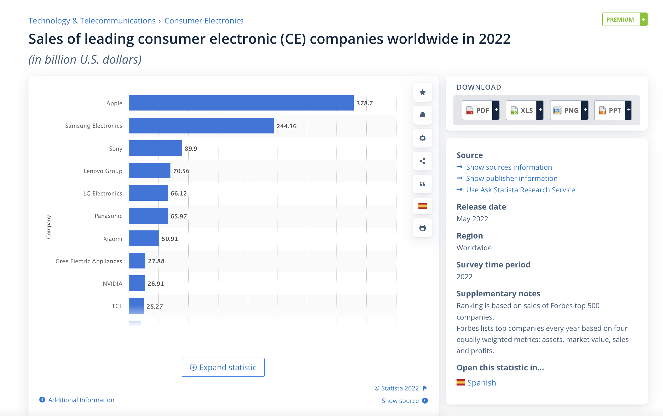

Figure S1. 22: Sales of leading consumer electronic (CE) companies worldwide in 2022. ©statista.com.[46]

Similar to the Google and Apple ecosystem, other products and service providers such as Amazon, Facebook, Baidu and WeChat have created new technology ecosystems with complex, mesmerizing functional matrices, which include traps which users may find difficult to escape.

Today, we are witnessing a repeat of patterns seen during former colonial periods Previously, empires heralded a prosperous and gratifying life to the indigenous people as their justification for colonization. Actually, they typified their colonization as a mission of *enlightenment*. Today, despite affirming unceasingly the motto of sharing the *highest benefit* to users (in theory, digital capital business is a process of benefit sharing), what is gained by users cannot be compared with the benefits achieved by corporations or organizations that own technology.

In The Wretched of the Earth, Frantz Fanon once stated:

‘The native must realize that colonialism never gives anything away for nothing.’ [47]

So *what* do tech owners exploit from their tech colonies?

If *natural resources* and *minerals* are the targets of exploitation by imperialist countries from their colonial territories, then in cyberspace, *data* is the most valuable resource.Information connectivity is a prerequisite for the existence of cyberspace. In other words, information becomes the primary fuel for every online connection. Storing, processing, analyzing, and transmitting information in the form of data sets is a fundamental activity in the digital space. The larger the amount of data, the more advanced the analysis ability, the higher value of the information obtained after the analysis, and the more applicability of that information. The *data mining*has become the spearhead industry of the technology empires.[48]

Therefore, rather than cyber-colonialism, Nick Couldry and Ulises Mejias proposed another concept – *data colonialism*. According to these authors, data colonialism is understood as ‘the extension of a global extraction process. It started under colonialism and continued through industrial capitalism, culminating in the present new form instead of natural resources and labor that has appropriated human life through its conversion into data.’[49] It can be said that owning data has become the foundation for governing today's technological colonies. In the year 2022, there were approximately 7.2 million data centers and server farms, the majority of which are, to this day, concentrated in developed countries, led by the US, Germany, the UK, China, and Canada.

~~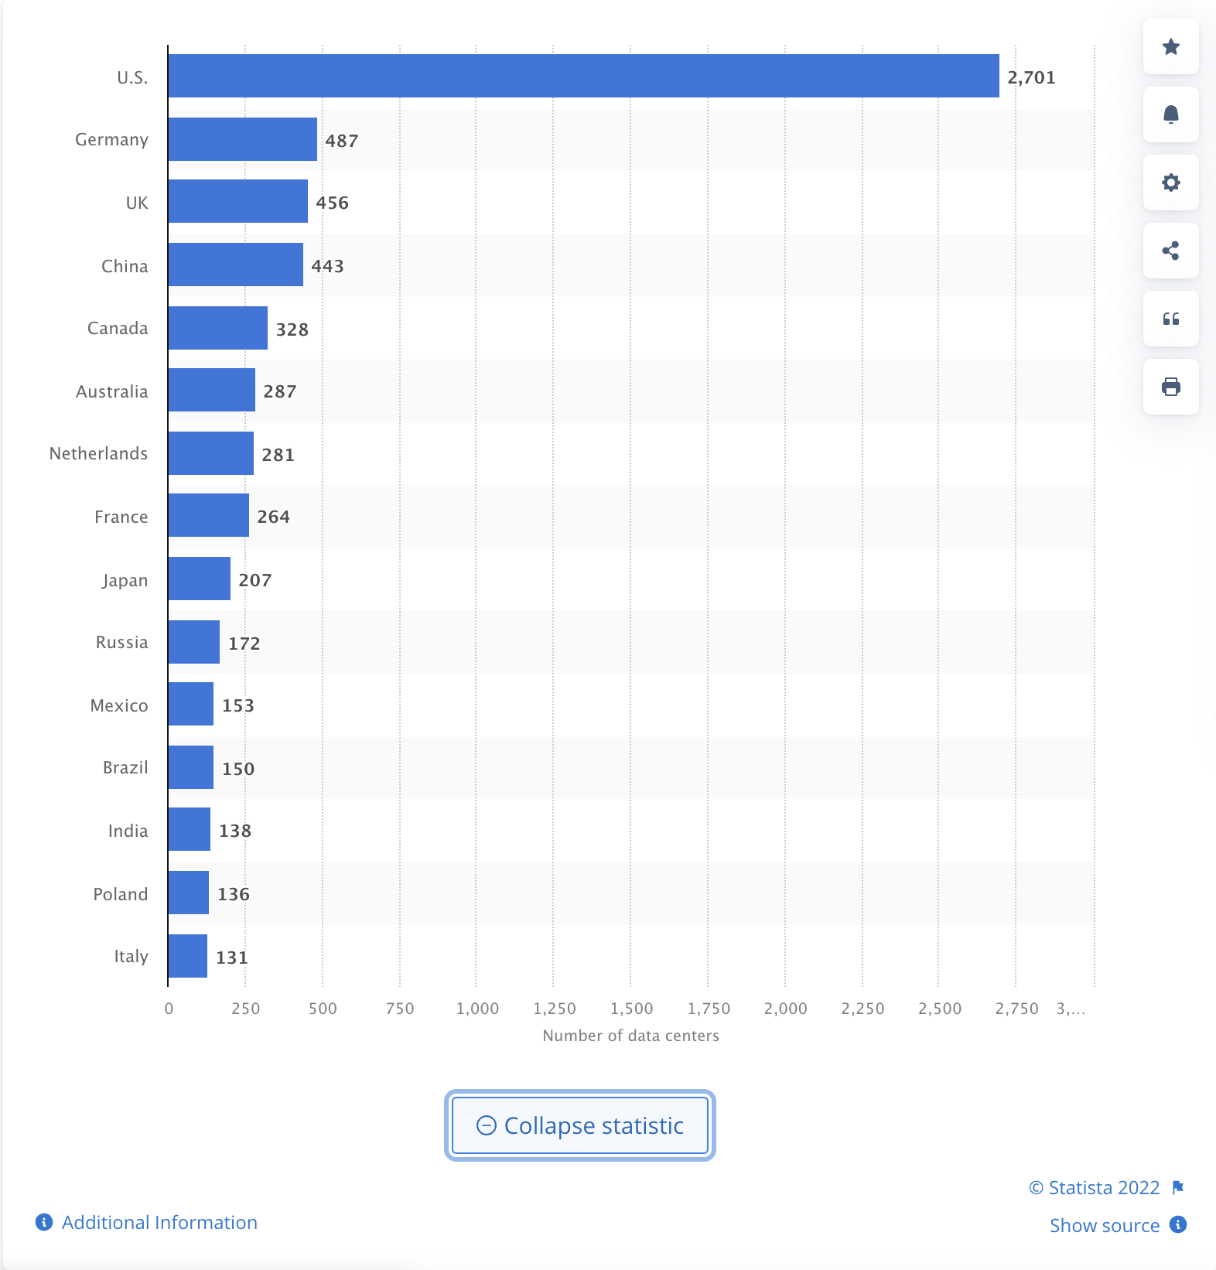~~

Figure S1. 23: Number of data centers worldwide in 2022, by country. ©statista.com.[50]

Moreover, since 2015, the number of hyperscale data centers has more than doubled.[51] The number of hyperscale data centers worldwide reached 700 by the end of 2021. The rapidly increasing number of hyperscale data centers worldwide in recent years illustrated the high level of power concentration in cyberspace.[52] Eve Tuck and K. Wayne Yang asserted, colonization ‘is not an approximation of other experiences of oppression’ but a highly distinctive exercise of power.[53]

Beyond the concept of *great power*, in the last 20 years, we have seen the world of technology dominated by *a small number* of *large global corporations*. This phenomenon of power concentration is evident in the characteristics of advanced-capitalistic societies, where industrial activity is concentrated in a few large firms.[54] The phenomenon of totalitarianism and domination of economic, political, cultural, and social activities of these large corporations, creates a *new form of empire* within capitalist society. Until now (2023), these technological empires were concentrated in the U.S and China. The Big Tech are often mentioned by mass media, such as Alphabet (Google), Amazon, Apple, and Meta (Facebook), Microsoft, Tesla, Twitter, Netflix, and they are representative of the information technology industry of the United States of America, while Tencent, Baidu, the Alibaba Group and Xiaomi are considered the Big Tech Four giants in China. Although they are considered U.S or Chinese technology companies, they have extensive global business in different respective areas of technology including artificial intelligence, e-commerce, online advertising, consumer electronics, cloud computing, computer software, media streaming, smart home, self-driving cars, and social networking. They are among the most valuable global public companies having a maximum market capitalization ranging from around $1 trillion to above $3 trillion.[55]

Based on their operational capacity, the scale of infrastructure, and real financial potential, these big global technology corporations are also the leaders in the professional development of the most advanced technologies, in particular, the advances in artificial intelligence and machine learning technology. The Big data systems combined with the new generation machine learning algorithms have brought deep analysis and self-making predictions or decisions. With new artificial intelligence systems, technology owners transform the present machine into a social judge which is able to identify users in terms of their social, political and ethnic groups. Machines can also work in place of skilled craftsmen, tour guides, and financial analysts. A new generation of virtual assistants is able to interact directly with humans to provide direction, answer questions and even chat emotively.

However, the fascinating achievements of machine learning technology and its unbelievable applications have created a new wave of concern around the ethics of of AI, recently giving rise to the concept of *AI colonialism*. In the article *Artificial intelligence is creating a new colonial world order* published at *MIT Technology Review* in April 2022, Karen Hao asserted: ‘It’s not possible to talk about ‘AI for everyone’ (Google’s rhetoric), ‘responsible AI’ (Facebook’s rhetoric), or ‘broadly distributing’ its benefits (Open AI’s rhetoric) without honestly acknowledging and confronting the obstacles in the way.’[56]

The threat of using the power of digital technology and AI to control and manipulate others has become a global concern in recent years. This is especially apparent in the way people experience the digitizing of their lives, the profound dependence on technological devices, and the loss of decision-making and autonomy. The enslavement is transferred from direct to indirect form through digital media and devices.



Figure S1. 24: Photo essay 01. More than 1.5 million Africans were shipped across the Atlantic Ocean between the 15th and 19th Centuries, ©nilepost.co.ug. More than 62.5 percent of the world's total population is internet Users in 2022, ©deviceatlas.com. Locking and tracking colonial slaves, ©t-vine.com. Personal tracking location, © gpsbob.com. Slave's stamp recognition, ©Wikimedia Commons. Facial recognition, ©Reuters. Brussels World fair 1958 ©Wikimedia Commons. Children’s rights in the cyberspace, ©theasianparent.com.[57], [58], [59], [60], [61], [62], [63], [64]



Figure S1. : Photo essay 02. The White Sea-Baltic Canal opened on 2 August 1933, ©dmitrievaffair.com. Daily, users are creating content and information values without payment, ©abcnews.go.com. Sale of Estates, Pictures and Slaves in the Rotunda, New Orleans; by William Henry Brooke, engraver; engraving with watercolor from The Slave States of America, vol. 1; London: Fisher and Son, 1842 ©wwno.org. The Big Data Privacy Problem. ©innovate-edu.com. Cape Town slaves to migrant gold miners, ©ucd.ie. Data Mining Techniques, ©justtotaltech.com.[65], [66], [67], [68], [69], [70]

If *weapons* were the main tools of colonization in the past, the new empires use *digital* and *social media* to control and manipulate people today. The majority technology owners today are also media holders that can influence or shape users' perceptions, beliefs, preferences, and desires, thereby directing users’ actions or decisions. There is no doubt that dominating perceptions is the most effective and dangerous way to possess human beings, influence their awareness and manipulate their action.

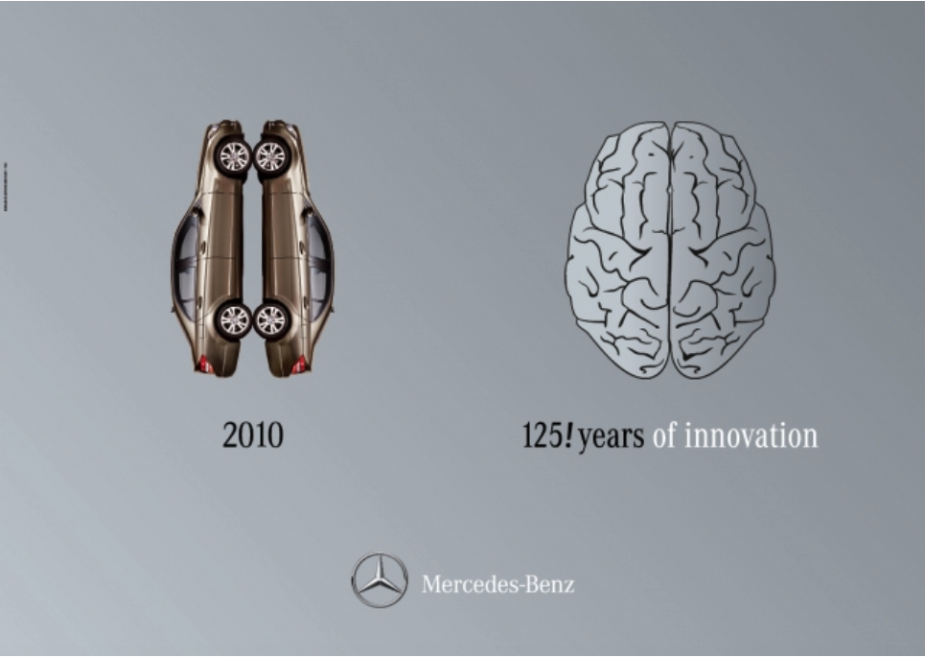

Figure S1. : Mecedes-Benz advertisment 2010. ©adsoftheworld.com.[71]

*Advertising* is considered an effective tool to influence perception, an indispensable tool in the colonization process in cyberspace. Currently, advertising remains the trump card, the main source of profit for many information technology empires. As advertising agencies, technology corporations are able to create information and control over the flow of that information. They use advanced algorithms to optimize what advertising should be generated or produced and what venues and which populations should be targeted with that advertising.

The lives of modern people are affected by information, especially advertising. With the support of new devices and high-tech, the advertising industry has reached a hyper-developed stage. Today's advertising is very diverse from audio, images, videos, texts and software. Delivery methods are multiple, from direct to indirect methods, by the influence of different digital tools such as email, search results or user experience. The profound effects of advertising on life have been proven throughout the 20th century and could become more dangerous in the 21st. Advertising is driving the whole spectrum of social activities. Advertising information instructs its users on various actions. These actions might include: electronic devices to use; places to travel; what to eat or drink; where to shop and what clothing to wear; where to reside; kinds of entertainment to choose; type of insurance to purchase; issues to discuss with friends; financial channels to be aware of; candidates to vote for in the next election; or even the person they should love!

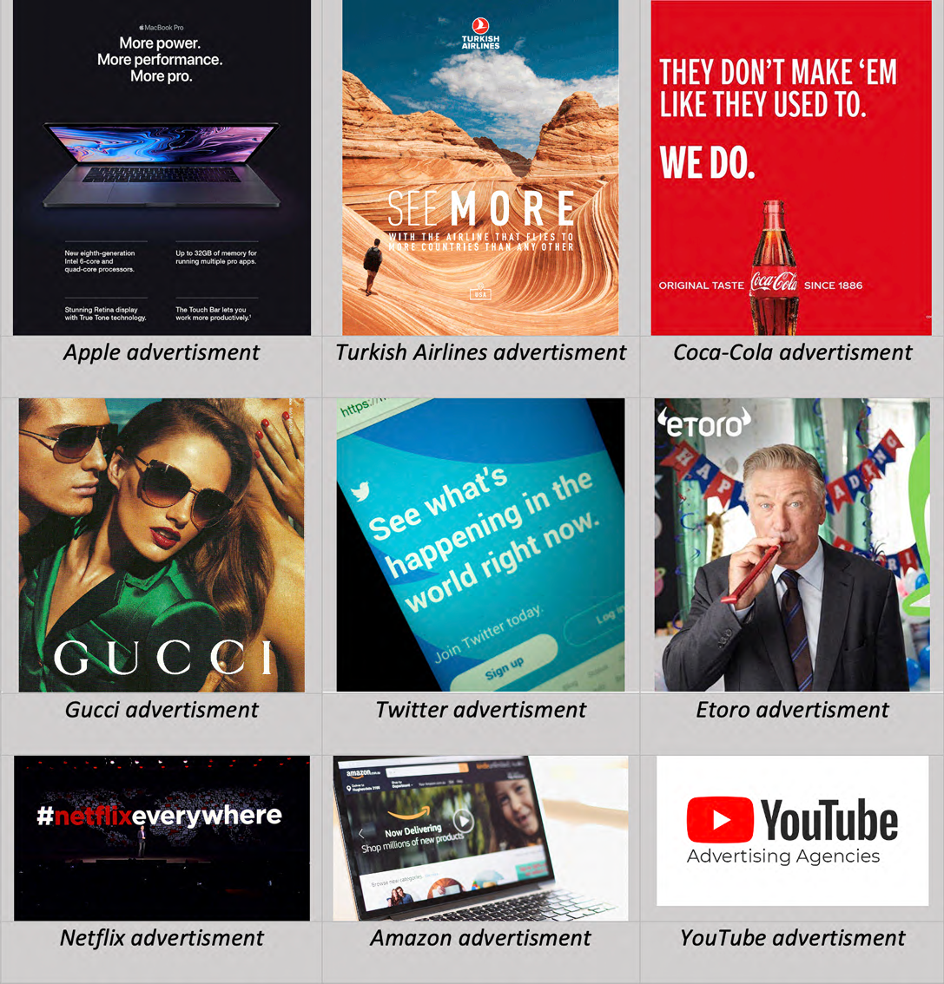

Figure S1. : Advertising is driving the whole spectrum of social activities. ©the author collects from various companies’ ads.

Technology owners appropriate not only the user’s body but also their *identity, emotions, spirit* and *self-determination*. That means the phenomenon of human exploitation has become a worrying reality in the global sphere in general and in the former colonial region in particular.

Today’s *cyber-colonization* process and the clever conspiracy of *personalization of services* have attempted to legitimize the appropriation of personal integrity and blinding or deceiving the users. ‘We'll serve you better if we know you better’ has become the rhetoric of all online products and service providers. The majority of users still do not fully understand the tactics of the process of ‘always listening, always understanding’from companies.[72] Behind electronic contracts (in the form of mandatory consent to dozens of pages of Terms and conditions), users consent to let service providers use their information legally when creating any electronic account. This process of accepting data collection is no different from inviting strangers into the home which gives them control over the owner's personal life from the living room to the dining room, to the bedroom, to the toilet. It has asserted that what today's tech corporations are collecting about users is more than the user can imagine; and that it is the foundation for technology owners to enslave users and colonize digital territories. Establishing superiority over others, tech owners are imposing unfair rules of the game on users globally.

In *Capital in the Twenty-First Century* (2013), Thomas Piketty of the *Paris School of Economics* asserted that ‘inequality is the inevitable consequence of economic growth in a capitalist economy and the resulting concentration of wealth can destabilize democratic societies and undermine the ideals of social justice upon which they are built’. That is the problem our society is facing. In particular, this *inequality* is becoming even more pronounced in some *developing countries* in the *Global South* - the southern hemisphere countries, which includes parts of Asia, Africa, and Latin America.

Many countries in the Global South have young populations, with a significant proportion of people under the age of 25.[73] This demographic shows a rich human resource and an energetic labor force, but it can also create challenges in terms of providing education, healthcare, and other basic services. These regions are often classified as developing economies, where the majority of people are still working in low and unstable conditions.[74] Among these countries, several have high levels of poverty, limited infrastructure, and significant income inequality.

The southern hemisphere countries are normally known as home to a wealth of natural resources, including oil, gas, minerals, and agricultural products. While these resources can be a source of economic growth, they can also lead to environmental degradation and social conflict. Many countries in the Global South have experienced political instability, including colonial periods, civil wars, coups, and other forms of unrest.[75] This instability creates many difficulties in implementing legal systems, and hardship in creating social and economic stability.

Nevertheless, the Global South market has been rapidly growing in recent years due to several factors, including increased access to digital technology and the proliferation of mobile devices.[76] With the increasing affordability of mobile devices, many people in the Global South are now able to access digital services such as social media, e-commerce, and mobile banking.

Generally, the characteristics of a large population are the cheap labor market, high consumer demand, low and uneven education level, weak social resistance, and ineffective legal barriers to new technologies. For this reason, the developing countries in The Global South are *potential exploitative markets* for new technology empires. *Vietnam* is one example of the type of market that is easily exploited.

Currently, Vietnam is one example of the type of market that is easily exploited. ‘IT labor suppliers in Southeast Asia, the main labor market tapped by developed countries in the region such as Japan’, Korea and Singapore.[77] Vietnam’s large and young population of consumers has also become a target of large technology corporations.

According to statistics provided by *hootsuite.com*, there were 72.10 million internet users in Vietnam in January 2022. Vietnam’s internet penetration rate stood at 73.2 percent of the total population at the start of 2022.

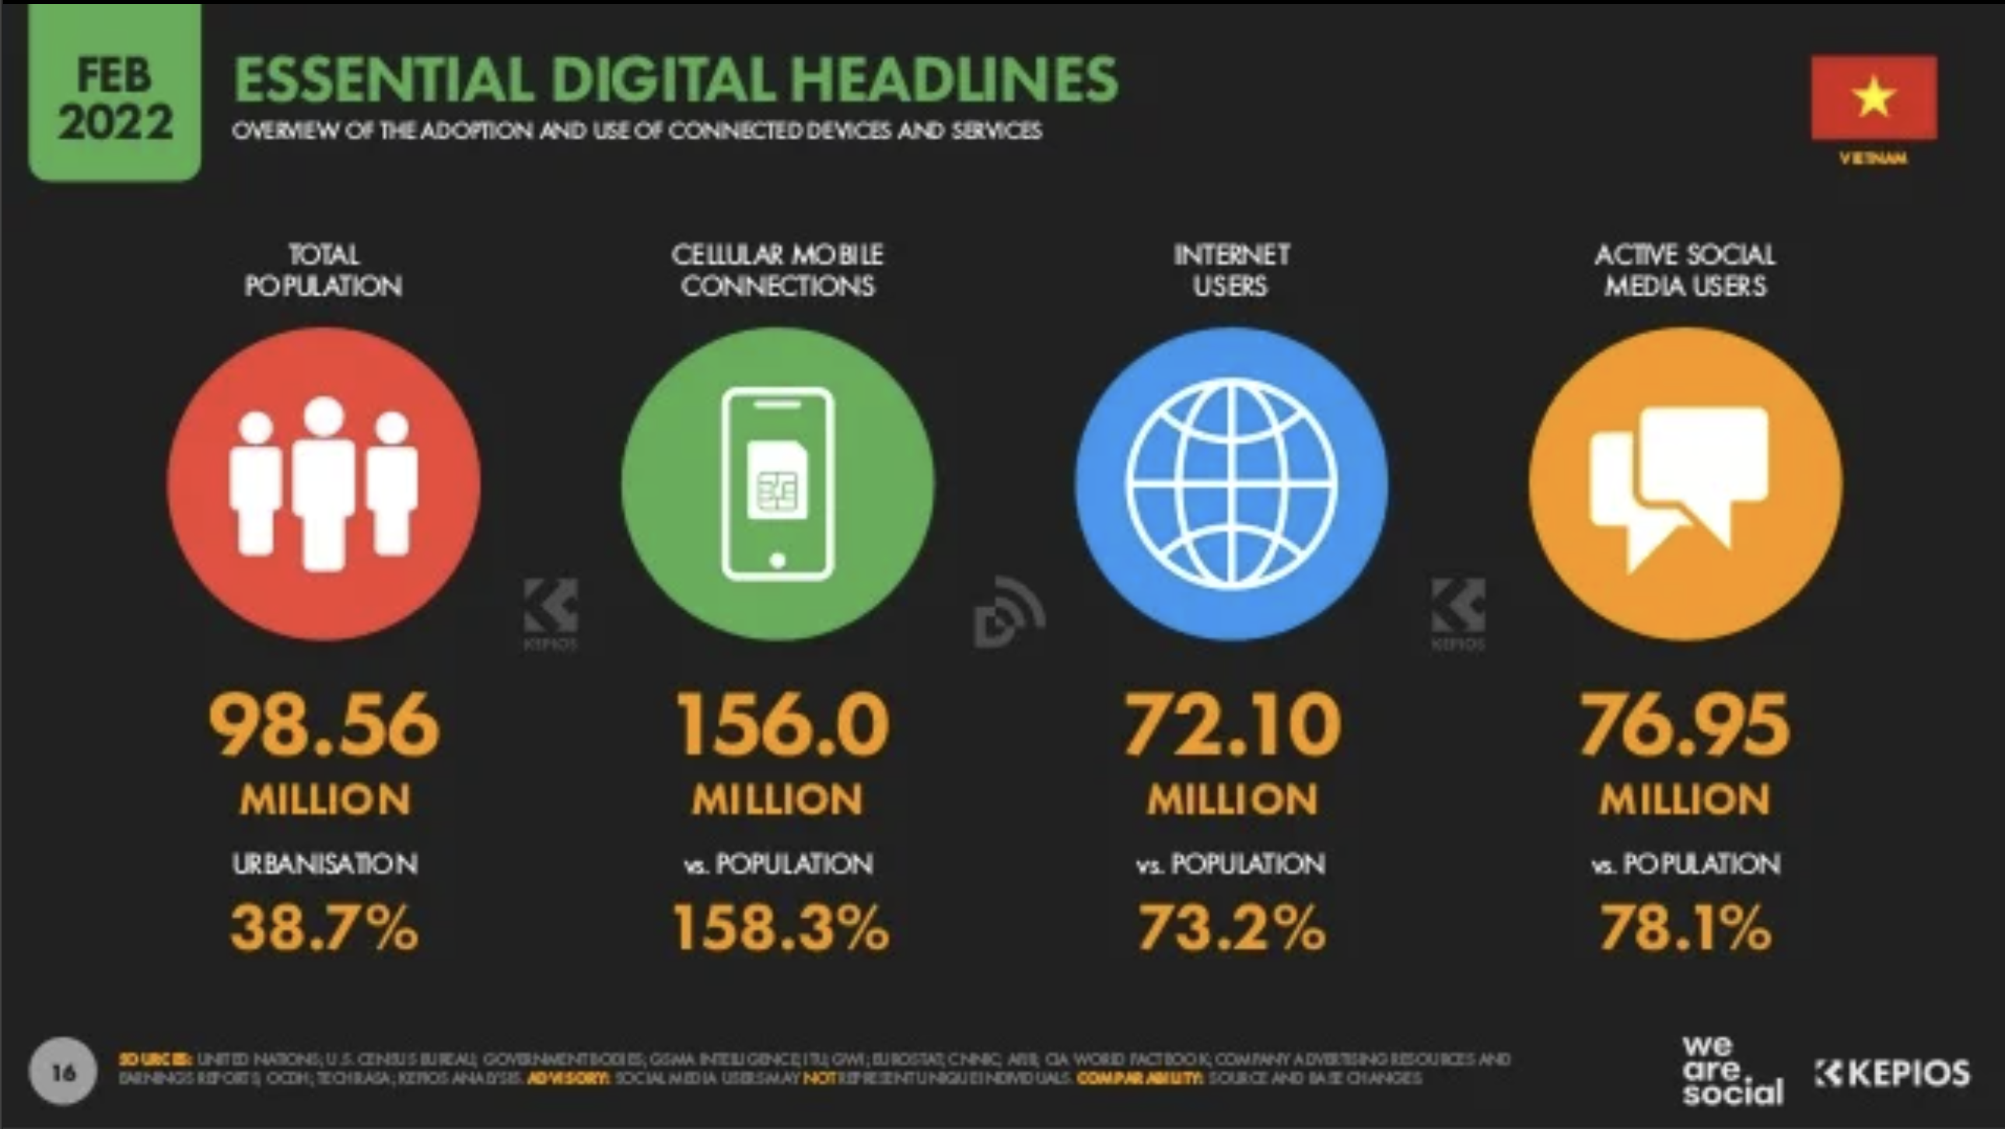

Figure S1. 28: Vietnam’s internet penetration rate. ©hootsuite.com.

On average, Vietnamese users daily spend 6 hours and 38 minutes each in cyberspace which is equivalent to the administrative working time of office workers and approximately one third of the total time they have daily.[78]

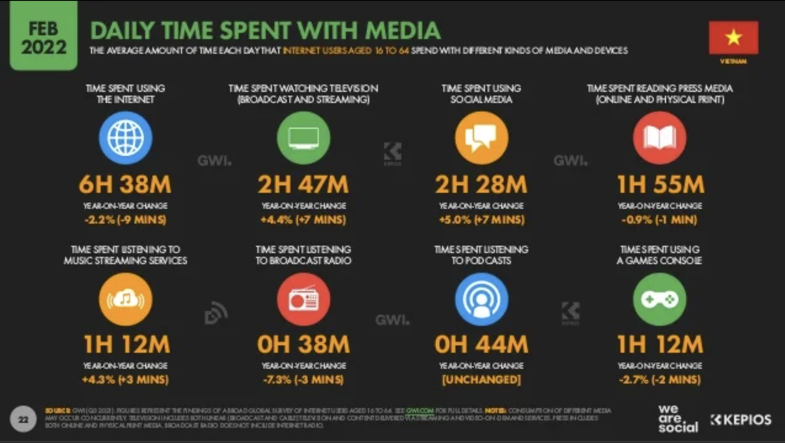

Figure S1. 29: Daily time spend with media ©hootsuite.com.

Vietnam ranked 13th on the list of countries with the largest digital populations in the world in 2022.[79] However, privacy in the internet space and Vietnam's cybersecurity index have always been among the lowest and most alarming in recent years.[80], [81], [82], [83]

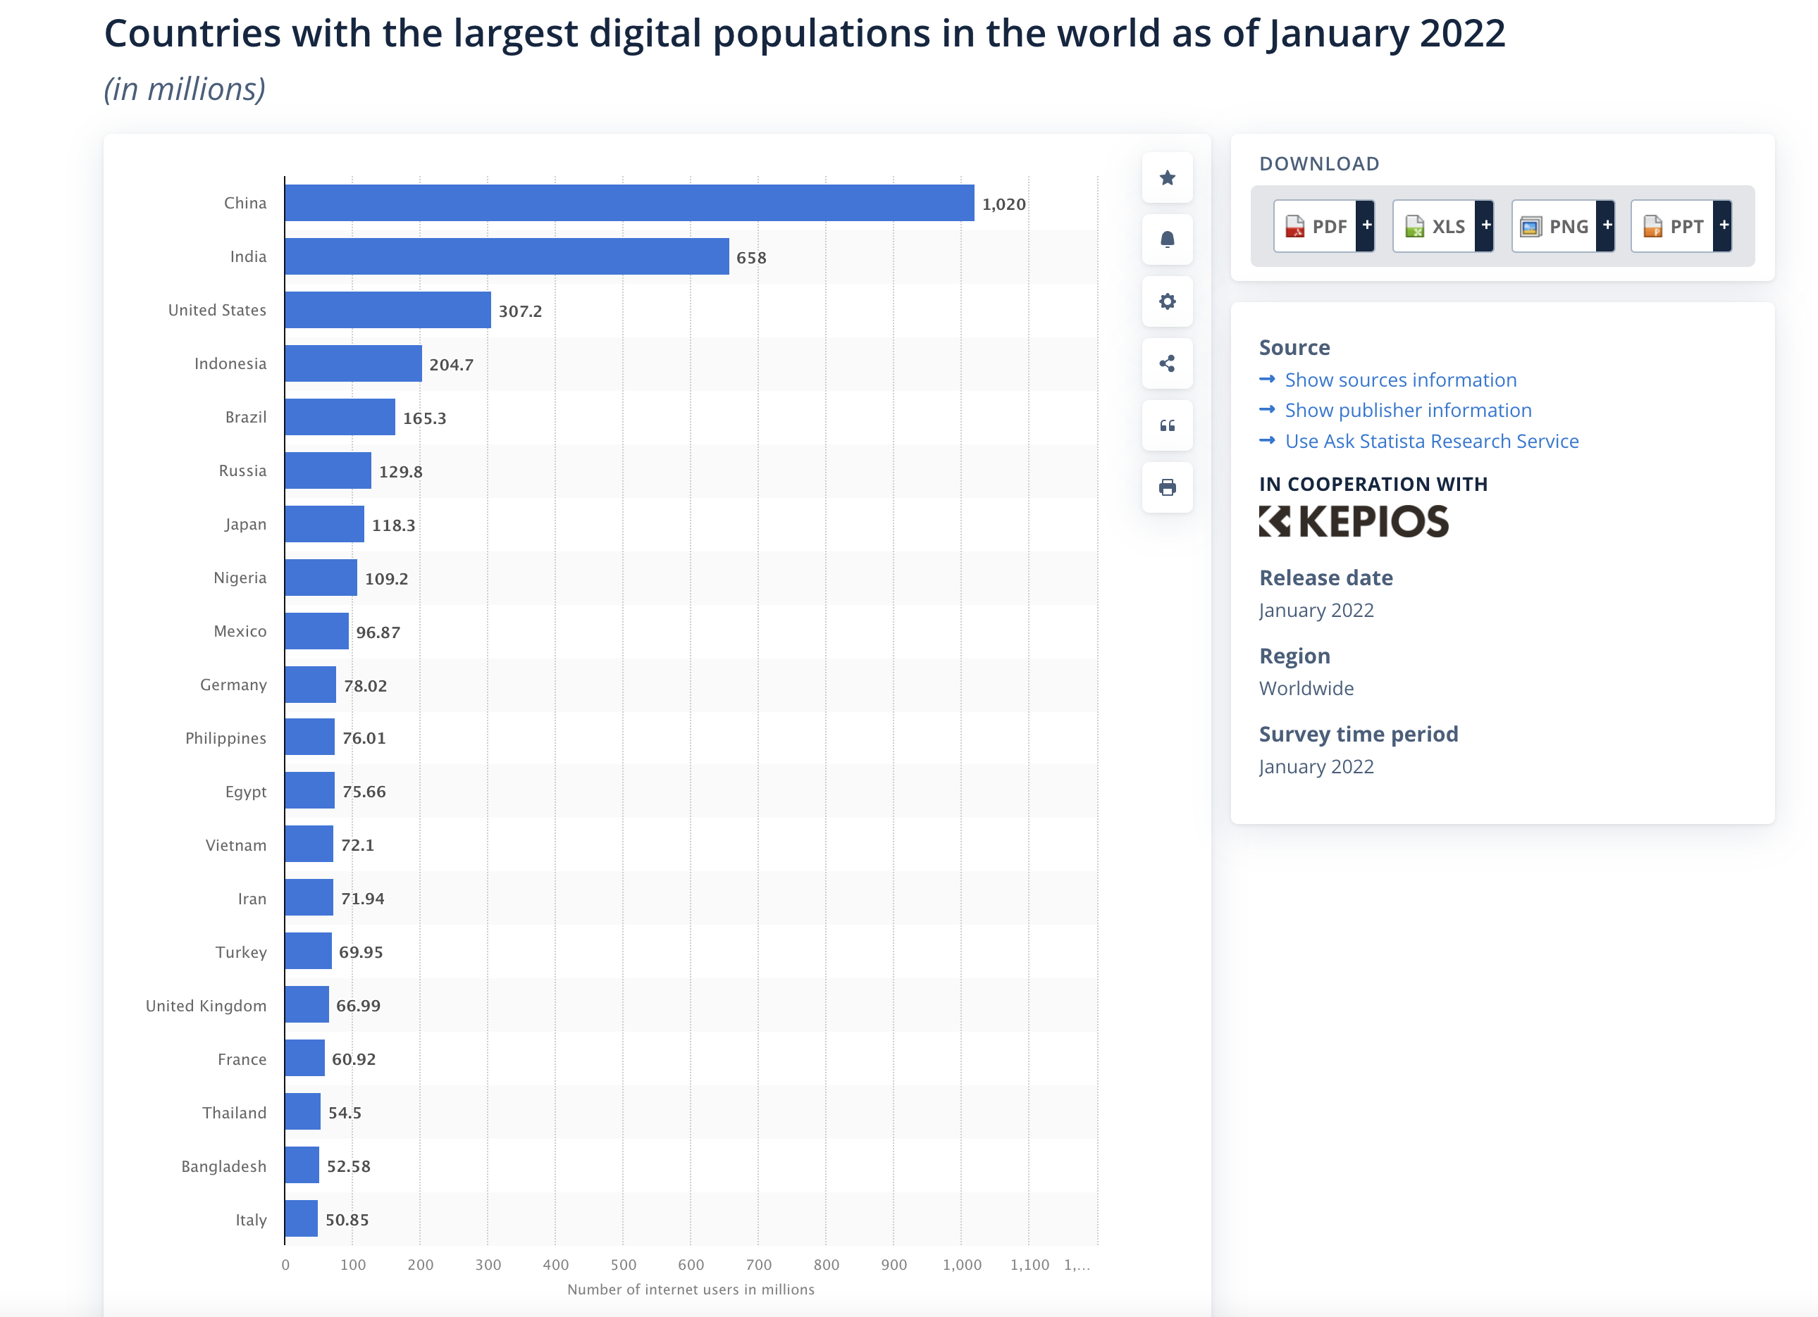

Figure S1. : Countries with the largest digital populations in the world as of January 2022.[84]

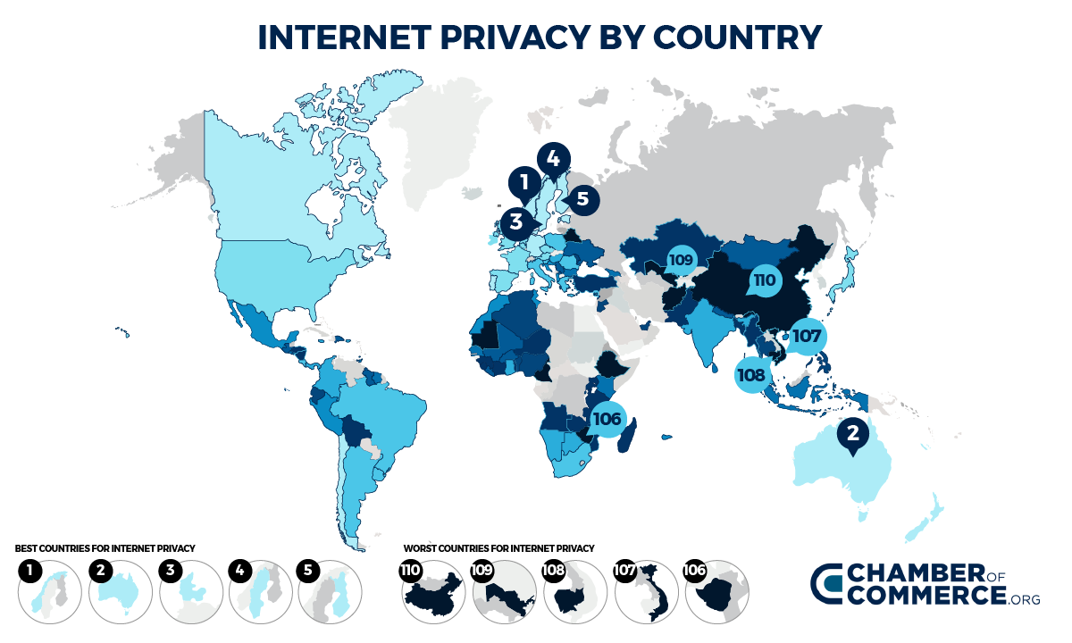

Figure S1. : Group of countries with low internet privacy and cybersecurity in the world ©Chamber of Commerce.org.

Vietnam's legal framework for privacy and cybersecurity is still in its early stages of development. Although Vietnam has passed several laws, including the Law on Protection of Personal Information, the Law on Cybersecurity, and the Law on Information Security, these legal regulations may not be comprehensive enough to address all the challenges and concerns of today’s digital world, especially emerging social phenomena related to artificial intelligence and machine learning-based automation.[85], [86] The implementation of these laws is often inadequate, and enforcement is often lax.[87] Corruption and bureaucracy are the main reasons that make law enforcement even less effective.

The densely populated market and ineffective law barriers are reasons why Vietnam has become a profitable market for global technology corporations. According to the statistical assessment of *We Are Social and Kepios*, Vietnam's digital advertising market is estimated to be worth $812.9 million by 2022.

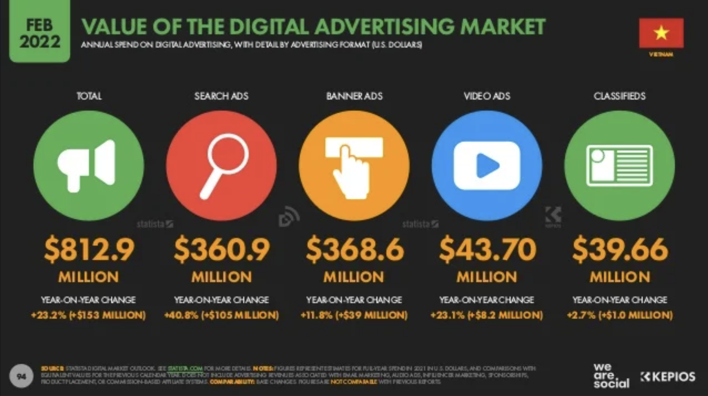

Figure S1. 32: Value of the digital advertising market ©hootsuite.com.

The Global South had been regarded as a potential market and a target by international traders as long as 200 years ago. For this reason, European merchants expanded their market and exploited colonies in the 18th and 19th centuries. Clearly, technology owners have a special preference for investing in this market in the 21st century.

All in all, the colonization process in cyberspace has been carried out through the social appropriation process, which imposes the power of technology owners on those who directly or indirectly use their products and services. Firstly, technology owners occupy digital territories through various digital markets such as mobile phones, computers, search, e-commerce, social networks and e-finance. Secondly, they possess the means and materials of digital production, in which machinery, equipment, and technology are the fundamental means, and data is the most valuable material. Together with the acquisition of a cheap workforce, the colonization of today also appropriates human identities, personal information, and individual decision-making. Through these appropriations, cyber-colonialism creates a new social order. Digital power-sharing dominates various aspects of life from political economy to culture, and these take place in many parts of the world, especially in developing countries.

**References**

Biney, Isaac K. ‘Revitalizing Blended and Self-Directed Learning Among Adult Learners Through the Distance Education Mode of Learning in Ghana.’ In *Re-Envisioning and Restructuring Blended Learning for Underprivileged Communities*, edited by IGI Global, 185-203, 2021.

Bischoff, Paul. ‘Cybersecurity Rankings by Country: Which Countries Have the Worst (and Best) Cybersecurity?’ *Comparitech*, 2022.

Boas, Marie. ‘Hero's Pneumatica: A Study of Its Transmission and Influence.’ *Isis 40*, no. 1 (1949): 38.

Couldry, Nick, and Ulises A. Mejias. *The Costs of Connection: How Data Is Colonizing Human Life and Appropriating It for Capitalism*. Stanford University Press, 2020.

Curtin, Philip D. ‘The End of the 'White Man's Grave'? Nineteenth-Century Mortality in West Africa.’ *The Journal of Interdisciplinary Histor*y 21, no. 1 (1990): 63-88.

Curtin, Philip D. ‘The White Man's Grave: Image and Reality, 1780-1850.’ *Journal of British Studies* 1, no. 1 (1961): 94-110.

Fanon, Frantz. *The Wretched of the Earth*. Translated by Richard Philcox. New York: Grove Press, 1963.

Farny, Eric. ‘Dependency Theory: A Useful Tool for Analyzing Global Inequalities Today*?’ E-International Relations*, June 19, 2016.

Frantzman, Seth J., and Kelsey D. Atherton. ‘Israel’s Rafael Integrates Artificial Intelligence into Spice Bombs.’ C4ISRNET, June 2019.

Habermas, Jürgen. *Legitimation Crisis*. Vol. 519. Beacon Press, 1975.

Hao, Karen. ‘Artificial Intelligence Is Creating a New Colonial World Order.’ *MIT Technology Review*, July 10, 2022.

Haraway, Donna. ‘A Cyborg Manifesto: Science, Technology, and Socialist-Feminism in the Late Twentieth Century.’ In *The Transgender Studies Reader*, 103-118. Routledge, 2013.

Headrick, Daniel R. ‘The Tools of Imperialism: Technology and the Expansion of European Colonial Empires in the Nineteenth Century.’ *The Journal of Modern History 51*, no. 2 (1979): 231-263.

Hussein, Fevzi. ‘Slavery Has Been Abolished for Over 200 Years – or Has It?’ *T-Vine*, August 2021.

Kemp, Simon. ‘Digital 2022: Vietnam.’ *DataReportal*, 2022.

Khokhar, Tariq. ‘Chart: How Is the World's Youth Population Changing?’ *World Bank*, 2017.

Kielty, James. ‘The Mobile Landscape in South Korea.’ DeviceAtlas, February 2019.

Levy, Ari. ‘Tech's Top Seven Companies Added $3.4 Trillion in Value in 2020.’ *CNBC*, 2020. Retrieved April 22, 2022.

Loo, Eric, and Yuen Shu Beng. ‘Cyber-Colonialism in Asia: More Imagined than Real?’ *Media Asia* 25, no. 3 (1998): 130-137. p. 1.

Lorge, Peter A. *The Asian Military Revolution: From Gunpowder to the Bomb*. Cambridge University Press, 2008.

Lowrie, William. *Fundamentals of Geophysics*. London: Cambridge University Press, 2007. p. 281.

Lưu Minh Sang, and Trần Đức Thành. ‘Trí Tuệ Nhân Tạo và Những Thách Thức Pháp Lý.’ Tạp Chí Khoa Học Công Nghệ Việt Nam, 2020.

Mayanja, Sam. ‘Opinion: Impact of Colonialism and Neo-Colonialism on African Economies.’ Nile Post, September 2022.

Mayor, Adrienne. *Gods and Robots: Myths, Machines, and Ancient Dreams of Technology*. Princeton University Press, 2018.

McPhail, Thomas L. *Global Communication: Theories, Stakeholders, and Trends*. Boston: Allyn and Bacon, 2002.

Mizokami, Kyle. ‘SR-71 Blackbird Pilot Reveals What It Was Like to Fly the Fastest Plane Ever.’ Popular Mechanics, 2020.

Muranaka, Akira. ‘Beyond Blue Ocean? The Roles of Intermediaries in the Cross‐Border Labour Market Between Japan and Vietnam.’ *Global Networks* 22, no. 3 (2022): 514-529.

Murgia, Madhumita. ‘Microsoft Quietly Deletes Largest Public Face Recognition Data Set.’ *Financial Times*, June 2019.

Ning, Lom. ‘Quinine and the Cinchona Plant: Gain or Bane for Africa?’ *Hektoen International: A Journal of Medical Humanitie*s, 2020.

Peixoto, Tiago, and Micah L. Sifry. *Civic Tech in the Global South: Assessing Technology for the Public Good*. Washington, DC: World Bank and Personal Democracy Press, 2017.

Rodney, Walter. *How Europe underdeveloped Africa.* Verso Books, 2018.

Sarafanov, Ivan, and Bai Shuqiang. ‘A Study on the Cooperation Mechanism on Digital Trade within the WTO Framework: Based on an Analysis on the Status and Barriers to Digital Trade.’ J. *WTO & China* 7 (2017): 17.

Strate, Lance. ‘The Varieties of Cyberspace: Problems in Definition and Delimitation.’ *Western Journal of Communication* 63, no. 3 (1999): 382-383.

Swift, Charles. ‘Robot Saints.’ *Preternature: Critical and Historical Studies on the Preternatural 4*, no. 1 (2015): 52-77.

Szondy, David. ‘Boston Dynamics' Latest Atlas Robot Struts Its Stuff.’ *New Atlas*. February 24, 2016. https://newatlas.com/boston-dynamics-new-atlas/42007.

Taylor, Andrew. *The Rise and Fall of the Great Empires*. London: Quercus, 2008.

Thorbecke, Catherine. ‘Facebook Tests Hiding Likes to See if It Will Change How People Engage with Posts.’ ABC News, September 2019.

Tilby, A. W. *Britain in the Tropics*, 1527-1910. Vol. 4. Houghton Mifflin, 1912.

1. Countries of the **Global South** have been described as newly industrialized or in the process of industrializing, and are frequently current or former subjects of colonialism. Wikipedia contributors, ‘Global North and Global South’, 20 October 2021, https://en.wikipedia.org/wiki/Global_North_and_Global_South.
2. **Millennial** is the first global generation and the first generation that grew up in the Internet age.
3. Margaret Kohn and Reddy Kavita, *Colonialism*, The Stanford Encyclopedia of Philosophy (Summer 2024 Edition), Edward N. Zalta & Uri Nodelman (eds.), https://plato.stanford.edu/entries/colonialism.
4. Walter Rodney, *How Europe underdeveloped Africa,* Verso Books, 2018.
5. Adrienne Mayor, *Gods and Robots: Myths, Machines, and Ancient Dreams of Technology,* Princeton University Press, 2018.
6. Marie Boas, ‘Hero's Pneumatica: A Study of Its Transmission and Influence’, *Isis 40*, no. 1 (1949): 38.
7. History of Information, ‘Automata Invented by Heron of Alexandria’, 25 October 2021, *historyofinformation.com*. https://www.historyofinformation.com/detail.php?id=10.
8. Charles Swift, ‘Robot Saints’, *Preternature: Critical and Historical Studies on the Preternatural 4*, no. 1 (2015): 52-77.
9. Andrew Taylor, *The Rise and Fall of the Great Empires*, London: Quercus, 2008.
10. Wikipedia contributors, ‘The Pharaoh Tutankhamun destroying his enemies’, 20 October 2021, https://commons.wikimedia.org/wiki/File:The_Pharaoh_Tutankhamun_destroying_his_enemies.jpg.
11. Wikipedia contributors, ‘Alexander Mosaic’, 20 October 2021, https://en.wikipedia.org/wiki/Alexander_Mosaic.
12. Vicifons, ‘Novum Organum/Liber Primus’, Liber I, CXXIX – Adapted from the 1863 translation, https://la.wikisource.org/wiki/Novum_Organum/Liber_Primus.
13. Wikipedia contributors, ‘The Diamond Sutra of the Chinese Tang dynasty, the oldest dated printed book in the world’, 20 October 2021, https://en.wikipedia.org/wiki/Papermaking#/media/File:Jingangjing.png.
14. Peter A Lorge, *The Asian Military Revolution: From Gunpowder to the Bomb*. Cambridge University Press, 2008.
15. Andrew Taylor, *The Rise and Fall of the Great Empires*. London: Quercus, 2008.
16. Wikipedia contributors, 'History of gunpowder', 20 October 2021, https://en.wikipedia.org/wiki/History_of_gunpowder#/media/File:Ming_artillerymen.jpg.
17. William Lowrie, *Fundamentals of Geophysics*. London: Cambridge University Press, 2007. p. 281.
18. Wikipedia contributors, 'History of the compass', 20 October 2021, https://en.wikipedia.org/wiki/History_of_the_compass#/media/File:Kardanischer-Kompass.jpg.
19. Wikipedia contributors, 'Cantino planisphere (1502)', 20 October 2021, https://en.wikipedia.org/wiki/File:Cantino_planisphere_(1502).jpg.
20. Wikipedia contributors, 'Medieval ships', 20 October 2021, https://en.wikipedia.org/wiki/Medieval_ships.
21. Wikipedia contributors, 'Industrial Revolution', 25 October 2021, https://en.wikipedia.org/wiki/Industrial_Revolution#/media/File:Hartmann_Maschinenhalle_1868_(01).jpg.
22. Wikipedia contributors, ‘World 1914 empires colonies territory’, 20 October 2021, https://commons.wikimedia.org/wiki/File:World_1914_empires_colonies_territory.PNG.
23. Wikipedia contributors, 'Steam Engine, Elevation plan and section of a steam-boat', 25 October 2021, https://commons.wikimedia.org/wiki/File:Steam_Engine,_Elevation_plan_and_section_of_a_steam-boat._Engraved_for_the_Encyclopedia_Londinensis_RMG_PU6673.jpg.
24. Wikipedia contributors, ‘Great Britain by Talbot’, 20 October 2021, https://en.wikipedia.org/wiki/File:SS_Great_Britain_by_Talbot.jpg.
25. Daniel R Headrick, ‘The Tools of Imperialism: Technology and the Expansion of European Colonial Empires in the Nineteenth Century.’ *The Journal of Modern History 51*, no. 2 (1979): 231-263.

    https://en.wikipedia.org/wiki/Machine_gun#:~:text=The%20first%20successful%20machine%2Dgun,by%20the%20United%20States%20Navy.
26. Wikipedia contributors, ‘History of hospitals’, 20 October 2021, https://en.wikipedia.org/wiki/History_of_hospitals.
27. Philip D Curtin, ‘The White Man's Grave: Image and Reality, 1780-1850.’ *Journal of British Studies* 1, no. 1 (1961): 94-110.
28. Lom Ning, ‘Quinine and the Cinchona Plant: Gain or Bane for Africa?’ *Hektoen International: A Journal of Medical Humanitie*s, 2020. https://hekint.org/2019/05/22/quinine-and-the-cinchona-plant-gain-or-bane-for-africa/.
29. Philip D Curtin, ‘The End of the 'White Man's Grave'? Nineteenth-Century Mortality in West Africa.’ *The Journal of Interdisciplinary Histor*y 21, no. 1 (1990): 63-88.
30. Aubrey Wyatt Tilby, *Britain in the Tropics*, 1527-1910, Vol. 4, Houghton Mifflin, 1912.
31. Wikipedia contributors, ‘Searchlight’, *wikiwand.com, 20 October 2021,* https://www.wikiwand.com/en/Searchlight.
32. Military History Now, ‘How Early Photographers Captured History’s First Images of War’, *militaryhistorynow.com,* 25 October 2021,

    https://militaryhistorynow.com/2012/06/12/how-early-photographers-captured-historys-first-images-of-war/
33. The Guardian, ‘Confronting the colonial archive – in pictures’, *theguardian.com,* 25 October 2021,

    https://www.theguardian.com/artanddesign/gallery/2019/nov/19/the-anthropologists-africa-in-pictures-faces-voices.
34. Akpool, ‘Postcard Saigon Cochinchine Vietnam, Camp des Mares, le Repas des Tirailleurs punis de prison’, *akpool.co.uk,* 25 October 2021, https://www.akpool.co.uk/postcards/27907351-postcard-saigon-cochinchine-vietnam-camp-des-mares-le-repas-des-tirailleurs-punis-de-prison.
35. David Szondy, ‘Boston Dynamics' Latest Atlas Robot Struts Its Stuff,’ *New Atlas*, 24 February 2016, https://newatlas.com/boston-dynamics-new-atlas/42007.
36. Kyle Mizokami, ‘SR-71 Blackbird Pilot Reveals What It Was Like to Fly the Fastest Plane Ever’, *Popular Mechanics*, 31 December 2020, https://www.popularmechanics.com/military/aviation/a35092143/sr-71-blackbird-pilot-interview-flying-fastest-plane-ever/.
37. Seth J Frantzman and Atherton Kelsey, ‘Israel’s Rafael Integrates Artificial Intelligence into Spice Bombs.’ *C4ISRNET*, June 2019.

    https://www.c4isrnet.com/artificial-intelligence/2019/06/17/israels-rafael-integrates-artificial-intelligence-into-spice-bombs/.
38. Christian Lous Lange, Norwegian historian, The Nobel Peace Prize 1921.
39. Thomas L McPhail, *Global Communication: Theories, Stakeholders, and Trends*. Boston: Allyn and Bacon, 2002.
40. Lance Strate, ‘The Varieties of Cyberspace: Problems in Definition and Delimitation.’ *Western Journal of Communication* 63, no. 3 (1999): 382-383. doi:10.1080/10570319909374648.
41. Eric Loo and Yuen Shu Beng, ‘Cyber-Colonialism in Asia: More Imagined than Real?’ *Media Asia* 25, no. 3 (1998): 130-137. p. 1.
42. Donna Haraway, ‘A Cyborg Manifesto: Science, Technology, and Socialist-Feminism in the Late Twentieth Century.’ In *The Transgender Studies Reader*, 103-118. Routledge, 2013.
43. Wikipedia contributors, ‘Social Credit System’, 20 October 2021, https://en.wikipedia.org/wiki/Social_Credit_System
44. First Site Guide, ‘Google Search Statistics and Facts 2022,’ *First Site Guide*, 2 March 2023,

    https://firstsiteguide.com/google-search-stats/
45. Statista, ‘Global revenue of Apple from 2004 to 2022’, *statista.com,* 2 March 2023,

    https://www.statista.com/statistics/265125/total-net-sales-of-apple-since-2004/
46. Statista, ‘Sales of leading consumer electronic (CE) companies worldwide in 2022’, *statista.com,* 2 March 2023, https://www.statista.com/statistics/431431/sales-of-the-leading-ce-companies-worldwide.
47. Frantz Fanon, *The Wretched of the Earth*. Translated by Richard Philcox, New York: Grove Press, 1963.
48. Data mining is the process of extracting and discovering patterns in large data sets involving methods at the intersection of machine learning, statistics, and database systems.

    Wikipedia contributors, ‘Data Mining’, 10 October 2022, https://en.wikipedia.org/wiki/Data_mining.
49. Nick Couldry and Mejias Ulises A, *The Costs of Connection: How Data Is Colonizing Human Life and Appropriating It for Capitalism*, Stanford University Press, 2020.
50. Statista, ‘Number of data centers worldwide in 2022, by country’, *statista.com*, 2 March 2023,

    https://www.statista.com/statistics/1228433/data-centers-worldwide-by-country/.
51. Hyperscale in computer science refers to a computing architecture that allows for the provision of highly scalable, high-performance computing resources for large-scale data centers, cloud computing, and other IT environments.
52. Statista, ‘Number of hyper scale data centers worldwide from 2015 to 2021’, *statista.com*, 12 March 2021,https://www.statista.com/statistics/633826/worldwide-hyperscale-data-center-numbers/.
53. Nick Couldry and Mejias Ulises A, *The Costs of Connection: How Data Is Colonizing Human Life and Appropriating It for Capitalism*, Stanford University Press, 2020.
54. Jürgen Habermas, *Legitimation Crisis*, Vol. 519, Beacon Press, 1975.
55. Ari Levy, ‘Tech's Top Seven Companies Added $3.4 Trillion in Value in 2020.’ *CNBC*, 2020.
56. Karen Hao, ‘Artificial Intelligence Is Creating a New Colonial World Order.’ *MIT Technology Review*, July 2022.
57. Sam Mayanja, ‘Opinion: Impact of Colonialism and Neo-Colonialism on African Economies.’ *Nile Post*, September 2022. https://www.nilepost.co.ug. https://nilepost.co.ug/2022/09/30/opinion-impact-of-colonialism-and-neo-colonialism-on-african-economies/.
58. James Kielty, ‘The Mobile Landscape in South Korea.’ *Device Atlas*, February 2019. https://deviceatlas.com/blog/mobile-landscape-south-korea.
59. Fevzi Hussein, ‘Slavery Has Been Abolished for Over 200 Years – or Has It?’, *T-Vine*, August 2021. https://www.t-vine.com/slavery-has-been-abolished-for-over-200-years-or-has-it/.
60. Gpsbob, ‘Home Plan GPS Tracking App & Software Free With Every Tracker Device’, *gpsbob.com*, February 2020, https://gpsbob.com/gps-tracking-app-software/.
61. Wikipedia contributors, ‘The Negro in American history’, 25 October 2021, https://vi.wikipedia.org/wiki/T%E1%BA%ADp_tin:The_Negro_in_American_history_%28microform%29_-_men_and_women_eminent_in_the_evolution_of_the_American_of_African_descent_%281914%29_%2814597416438%29.jpg.
62. Madhumita Murgia, ‘Microsoft Quietly Deletes Largest Public Face Recognition Data Set.’ *Financial Times*, June 2019. https://www.ft.com/content/7d3e0d6a-87a0-11e9-a028-86cea8523dc2.
63. Wikipedia contributors, ‘Human Zoo’, 10 October 2022, https://en.wikipedia.org/wiki/Human_zoo#/media/File:African_Girl,_1958_Expo.jpeg.
64. The Asian Parent, ‘Children’s Rights in the Cyberspace’, *The Asian Parent*, 2016, https://sg.theasianparent.com/parents-posting-naked-picture-children-online-sparks-debate.
65. Dmitriev Affair, ‘Deaths on the White Sea Canal, 1931-1933’, 19 September 2019. https://dmitrievaffair.com/deaths-on-the-white-sea-canal/.
66. Catherine Thorbecke, ‘Facebook Tests Hiding Likes to See if It Will Change How People Engage with Posts.’ *ABC News*, September 2019. https://abcnews.go.com/Business/facebook-tests-hiding-likes-change-people-engage-posts/story?id=65901080.
67. WWNO, ‘Sighting the Sites of the New Orleans Slave Trade.’ *WWNO*, November 2015. https://www.wwno.org/podcast/tripod-new-orleans-at-300/2015-11-05/sighting-the-sites-of-the-new-orleans-slave-trade.
68. Innovate Edu, ‘The Big Data Privacy Problem.’ *Innovate Edu*, September 2014. https://innovate-edu.com/2014/09/.
69. WWNO, ‘Sighting the Sites of the New Orleans Slave Trade.’ *WWNO*, November 2015.
70. University College Dublin, ‘Cape Town Slaves to Migrant Gold Miners: A Colonial Continuum in South Africa,’ *Stories of Discovery*, 15 September 2021. https://www.ucd.ie/discovery/storiesofdiscovery/capetownslavestomigrantgoldminers-acolonialcontinuuminsouthafrica.html.
71. Y&R, ‘Mercedes Right Brain - Left Brain.’ *Ads of the World,* 15 September 2021*.* https://www.adsoftheworld.com/campaigns/right-brain-left-brain.
72. The slogan of Prudential - a British multinational insurance company.

    Prudential, ‘Always Listening, Always Understanding,’ *Our History*, 21 November 2022, https://www.prudential.com.sg/about/our-history.
73. Tariq Khokhar, ‘Chart: How Is the World's Youth Population Changing?’ *World Bank*, 2017. https://blogs.worldbank.org/opendata/chart-how-worlds-youth-population-changing.
74. Eric Farny, ‘Dependency Theory: A Useful Tool for Analyzing Global Inequalities Today*?’ E-International Relations*, 19 June 2016.

    https://www.e-ir.info/2016/11/23/dependency-theory-a-useful-tool-for-analyzing-global-inequalities-today.
75. Isaac K. Biney, ‘Revitalizing Blended and Self-Directed Learning Among Adult Learners Through the Distance Education Mode of Learning in Ghana.’ In *Re-Envisioning and Restructuring Blended Learning for Underprivileged Communities*, edited by IGI Global, 185-203, 2021.
76. Tiago Peixoto and Micah L. Sifry, *Civic Tech in the Global South: Assessing Technology for the Public Good*, Washington, DC: World Bank and Personal Democracy Press, 2017.
77. Akira Muranaka, ‘Beyond Blue Ocean? The Roles of Intermediaries in the Cross‐Border Labour Market Between Japan and Vietnam.’ *Global Networks* 22, no. 3 (2022): 514-529.
78. Simon Kemp, ‘Digital 2022: Vietnam.’ *DataReportal*, 1 March 2022.

    https://datareportal.com/reports/digital-2022-vietnam?rq=vietnam.
79. Statista, ‘Countries with the largest digital populations in the world’, *statista.com*, 12 March 2022, https://www.statista.com/statistics/262966/number-of-internet-users-in-selected-countries/.
80. Hiền Minh, ‘Dự Báo An Ninh Mạng Năm 2022.’ *Báo Chính Phủ*, 2022, https://baochinhphu.vn/du-bao-an-ninh-mang-nam-2022-102220119142521952.htm.
81. Ivan Sarafanov and Bai Shuqiang, ‘A Study on the Cooperation Mechanism on Digital Trade within the WTO Framework: Based on an Analysis on the Status and Barriers to Digital Trade.’ *J. WTO & China* 7 (2017): 17. https://www.researchgate.net/figure/Legislations-on-Data-Protection-and-Privacy-Across-the-World-Source-UNCTAD-2015-Data-at_fig4_330411763.
82. Paul Bischoff, ‘Cybersecurity Rankings by Country: Which Countries Have the Worst (and Best) Cybersecurity?’ *Comparitech*, 2022. https://www.comparitech.com/blog/vpn-privacy/cybersecurity-by-country/.
83. e-Governance Academy Foundation, ‘National Cyber Security Index’, 12 March 2023, https://ncsi.ega.ee/ncsi-index/.
84. Statista, ‘Countries with the largest digital populations in the world’, *statista.com*, 12 March 2022, https://www.statista.com/statistics/262966/number-of-internet-users-in-selected-countries/.
85. NACIS, ‘Pháp Luật Hiện Hành Của Việt Nam Về Bảo Vệ Dữ Liệu Thông Tin Cá Nhân và Quyền Riêng Tư.’ *NACIS*, 15 March 2022. https://nacis.gov.vn.
86. Thư viện pháp luật, ‘Luật an ninh mạng’, *Thư viện pháp luật*, 15 March 2022. https://thuvienphapluat.vn/van-ban/Cong-nghe-thong-tin/Luat-an-ninh-mang-2018-351416.aspx.
87. Lưu Minh Sang and Trần Đức Thành, ‘Trí Tuệ Nhân Tạo và Những Thách Thức Pháp Lý.’ *Tạp Chí Khoa Học Công Nghệ Việt Nam*, 2020. https://vjst.vn/vn/tin-tuc/3303/tri-tue-nhan-tao-va-nhung-thach-thuc-phap-ly.aspx.